Notes

Challenging Poem
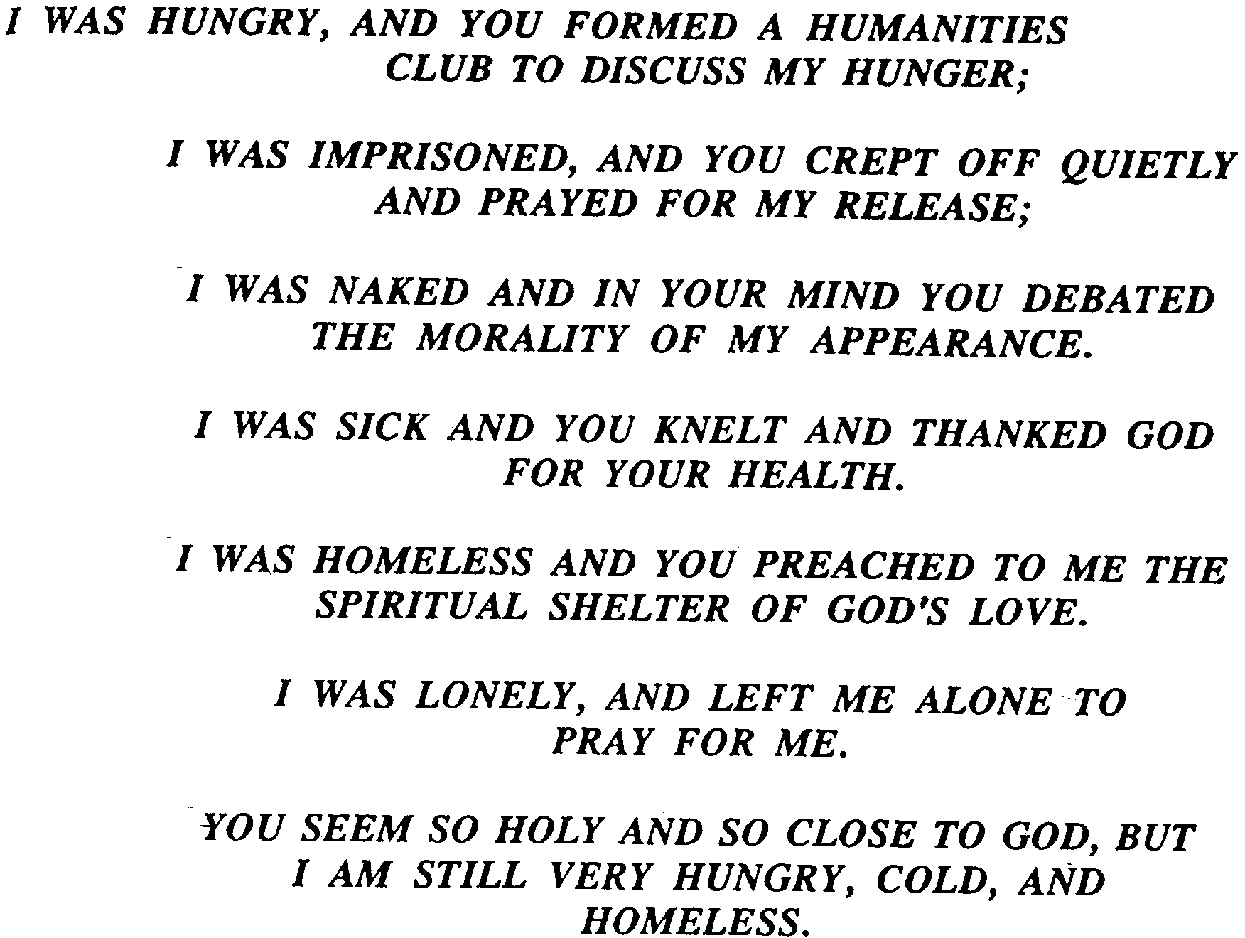

Feb 11th 2018

Contagious Christianity

Part 2
“Friend of Sinners”

Welcome

Contagious Christianity – Part 2
“Friend of Sinners”
(Lessons from the Master)

Jesus, sinners & fragrances - 2 Corinthians 2:15

- Luke 7:36-50 (The Pharisee, Jesus & the sinner woman)
Sinners are attracted to God’s presence.
They place value on it.
Jesus accepted her worship and closeness.
Religious people put up barriers against sinners.
(Which they don’t even keep for themselves).
Religiosity knows a lot about sin but little about grace.

- John 12:3-4 (Mary, Martha Lazarus & …Judas)

Her act of worship was received by the Lord.
It impacted the atmosphere.
Judas’ response was corrupt: he really didn’t have a heart for the poor.
Don’t judge someone else’s generosity by your own issues.

- Matthew 26:6-9 (Jesus, Simon the leper, the woman & the disciples)

Jesus regularly ‘crossed the line’ to go into despised sinners turf.
All the disciples were still learning what His heart was for people.

Final Take Away & Communion

John 1:16-17
¹⁶ And of His fullness we have all received, and grace for grace.
¹⁷ For the law was given through Moses,
but grace and truth came through Jesus Christ.

Jesus wants us to spread the fragrance of His “unmerited favor”
to people in a variety of settings: on their turf even.

To reflect on

“Far too many Christians have been anesthetized into thinking that if they simply live out their faith in an open and consistent fashion, the people around them will see it, want it, and somehow figure out how to get it for themselves.” – Bill Hybels

(Pastor of Chicago megachurch of over 15,000)

The Word says:

Mark 16:15
⁵ And He said to them, “Go into all the world and preach the gospel to every creature.

So, talking the message is vital.

