Notes

March 25th 2018

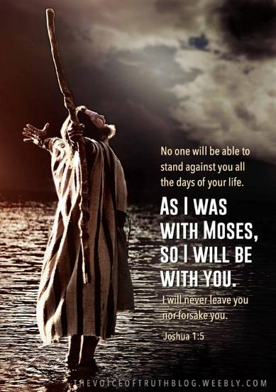

Possess the Land - 3
“Patience / Palm Sunday / Passover”

Welcome

Possess the Land – Part 3

The struggle (& choice) we face:

The struggle is the ‘gap’ between what God has promised …
… and the circumstances that stand in the way.
One kind of ‘truth’ - up close & in your face.
(Real circumstances) – ‘lower’ truth.
The other ‘truth’ seems so far away:
(God’s unchanging promises) – ‘higher’ truth.
Which ‘report’ will we believe?

The ‘choice’is to stand our ground:
(while we wait patiently)
Things often play out through time. Galatians 5:22

Moses started off as a “basket case”

1st 40 years: Grows up in Egypt.
(Privileged).
2nd 40 years: Seemingly forgotten in the wilderness of self-exile.
(After his felony)
3rd 40 years: leads God’s people in the wilderness.
(Before Joshua takes over from Moses).

How do you think Joshua & Caleb felt while waiting for things to play out after the show-down at Kadesh Barnea? – after only 3 weeks into the journey.

Deuteronomy 8:7-10
Process over time & certainty.

Hebrews 6:12b
(You inherit stuff after the death of another)

Application:
When we allow our own ‘fleshly’ efforts to die,
Then
God is then ‘freed’ to do what He has promised us:
To give us the land as His Grace (undeserved) gift.

In short: James 1:2-4
…the result – you will lack nothing.

On another note: (Palm Sunday)

The Jews in Jesus day had been waiting for a conquering Messiah
(the “Son of David”).
So, on the very day Jesus rode into Jerusalem on a donkey through
the Eastern gate for the Passover feast…
…the Roman Governor rode into town on a majestic horse through the Western gate to ensure that things stayed stable among the crowds.

The contrast:
Conquer by force & servitude or by love & service

The week before Easter: John 12:12-14

(Quote from a prophecy over 500 years before…talk about patience!)
Zechariah 9:9

The Passion Week:

The week before Passover (Palm Sunday)
Jesus is warmly welcomed as “King”.

During the week: tension builds and becomes volatile.
People enslaved to the ‘system’: Politoco - religious control)

End of the week: (Passover) The crowd’s manipulated & calls for crucifixion.
God’s ways are not our ways.

Final Take Away & Communion

The ‘Way of the Cross’ - (shame / ridicule / death)
Is God’s way to: Kingship!
Today,
Because His work was done on our behalf
We are to receive His grace in this by faith.
We can’t earn kingship: - only receive it.

