Prayer Focus This Week

Ephesians 1:15-21
¹⁵ Therefore I also, after I heard of your faith in the Lord Jesus and your love for all the saints, ¹⁶ do not cease to give thanks for you, making mention of you in my prayers: ¹⁷ that the God of our Lord Jesus Christ, the Father of glory, may give to you the spirit of wisdom and revelation in the knowledge of Him, ¹⁸ the eyes of your understanding being enlightened; that you may know what is the hope of His calling, what are the riches of the glory of His inheritance in the saints, ¹⁹ and what is the exceeding greatness of His power toward us who believe, according to the working of His mighty power ²⁰ which He worked in Christ when He raised Him from the dead and seated Him at His right hand in the heavenly places, ²¹ far above all principality and power and might and dominion, and every name that is named, not only in this age but also in that which is to come.

Pray with thanksgiving that God will give you (and yours):

- The spirit of wisdom & revelation in the knowledge of Him,

So that you can enjoy and fulfill:

The hope of His calling on your life,

The riches of His glory of His inheritance in the saints,

What the exceeding greatness of His power towards us.

Exercise:
Pray this every day this week as your first or principal prayer

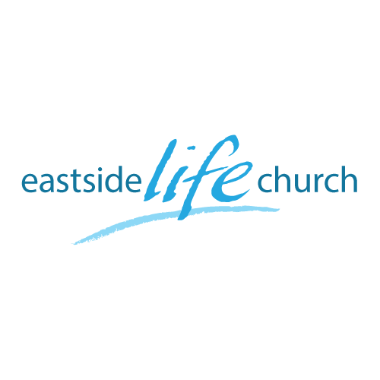
August 12th 2018

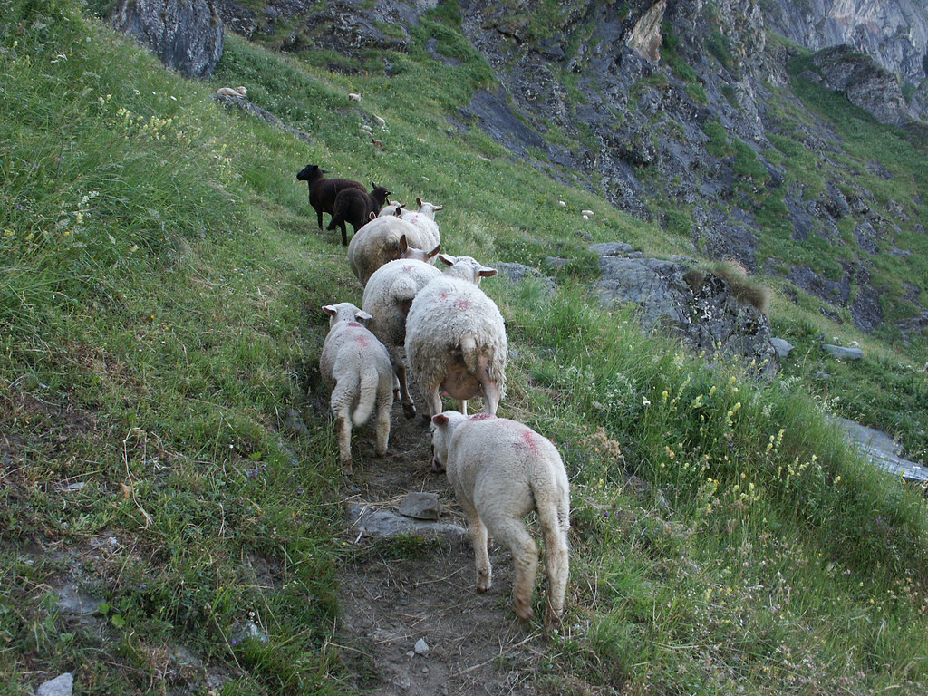

Walking in Freedom - 4
“Wisdom – the principal thing”

Welcome
The first Sunday of the Rest (Best) of your life

2018

Walking in Freedom – Part 5
Wisdom the principal thing

Foundational Scripture

Jeremiah 6:16
This is what the LORD says: "Stand at the crossroads and look; ask for the ancient paths, ask where the good way is, and walk in it, and you will find rest for your souls.

Our Good Shepherd leads us along these tried & tested paths.

The Pathway of Wisdom

“The ability to discern or judge what is true, right, or lasting; insight.
The sum of learning through the ages; knowledge:”

Recognizing ‘wisdom’ from above …,and below.

James 3:15-16 – wisdom from below.
James 3:17 – wisdom from above

Where wisdom comes from, and how to get it.

From God’s Word enlightened by His Spirit.
The Word is the grid, His Spirit helps apply it to your life:

Proverbs 2:6 / 2 Timothy 3:14-15

? Ask ? To get wisdom, ask for it.
James 1:5-6

Young Solomon asks for wisdom to fulfill his calling
1 Kings 3:5,9, 28

The fruit of Solomon’s wisdom “Impacts the world”

1 Kings 4:34
People from all nations came to hear Solomon's display of wisdom; they came from all the kings of the earth who heard about his wisdom.

The 7-fold Jewish Menorah
(Crafted by Bezalel) - Exodus 35:30-32

May the Lord help us craft a life founded on the 7 pillars of wisdom.

Final Take Away & Communion
As we celebrate Communion, know that

God’s wisdom often appears foolish to so called worldly-wise.

1 Corinthians 1:18
For the word of the cross is to them that perish foolishness, but to us that are saved it is God's power.

