Prayer Focus This Week

Take this scripture and pray this over yourself and your family each day this week:

Numbers 6:24 – 27
“The Lord bless you (me) and keep you (me); The Lord make His face to shine upon you (me), and be gracious to you (me). The Lord lift up His countenance on you (me), and give you (me)peace.
“In Jesus Name, Amen.”

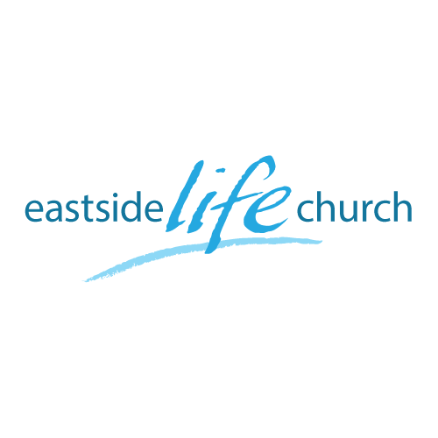
August 19th 2018

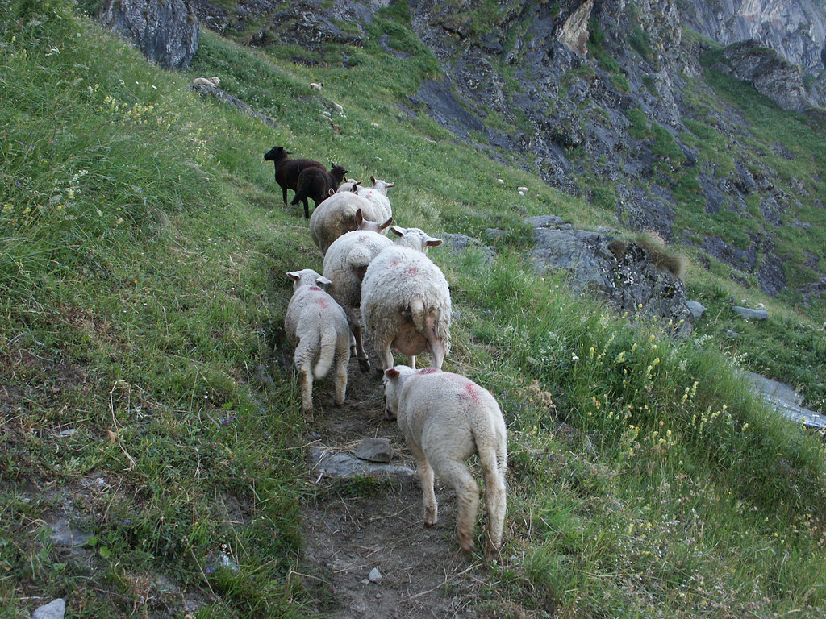

Walking in Freedom - 5
“We are blessed”

Welcome
The first Sunday of the Rest (Best) of your life

2018

Walking in Freedom – Part 5
“We are Blessed”

Foundational Scriptures:

Jeremiah 6:16
This is what the LORD says: "Stand at the crossroads and look; ask for the ancient paths, ask where the good way is, and walk in it, and you will find rest for your souls.

We are blessed

God’s heart is to bless us.

What about generational curses: should we rather focus on generational blessings??

The freedom that is inherent in our new position in Christ.
2 Corinthians 5:17

Patterns of iniquity’ have been dealt with: Isaiah 53:4-5

Back in the day…first mention of blessing:
Genesis 12:1-3

The cycle of blessing: “Blessed to be a blessing”

What is “The Blessing”?
“A state of well-being and favor that our loving heavenly Father

Ephesians 1:3
Blessed be the God and Father of our Lord Jesus Christ, who has blessed us with every spiritual blessing in the heavenly places in Christ,…

Is this ‘blessing’ merely and only spiritual?

We can know through:
- Human experience: Luke 11:13
- What Jesus reveals about Our Father: Mark 10:13-16

Final Take Away & Communion
As we celebrate Communion, know that…

Jesus the game changer
has redeemed us from the curse.

Galatians 3:13-14
¹³ Christ has redeemed us from the curse of the law, having become a curse for us (for it is written, “Cursed is everyone who hangs on a tree”), ¹⁴ that the blessing of Abraham might come upon the Gentiles in Christ Jesus, that we might receive the promise of the Spirit
through faith.

This took place at the cross.
Blessing is our new default position in Him.

