Notes

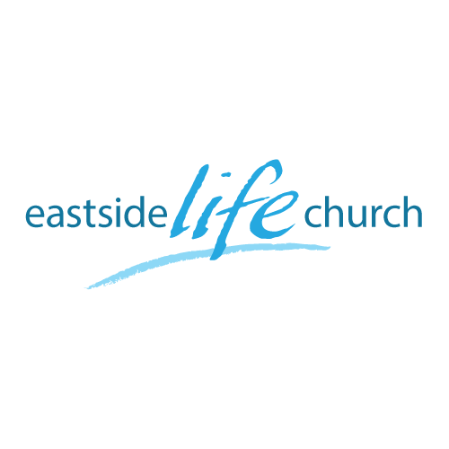
November 18th. 2018

All the Help You Need - 4
“ Help to overcome difficulties”

Welcome
The first Sunday of the Rest (Best) of your life

2018

All the Help You Need– Part 4
“Help to overcome difficulties”

John 16:7
Nevertheless I tell you the truth. It is to your advantage that I go away; for if I do not go away, the Helper will not come to you; but if I depart, I will send Him to you.

The Holy Spirit helps us in a key area…

Thanksgiving
In the face of difficulties

In everything give thanks?

I Thessalonians 5:16-18
¹⁶ Rejoice always, ¹⁷ pray without ceasing, ¹⁸ in everything give thanks; for this is the will of God in Christ Jesus for you.

‘Give thanks’ – our choice

2 Corinthians 2:14
Now thanks be unto God, who always causes us to triumph in Christ,

Adverse circumstances are designed to ‘separate’ us from a vital, sustaining relationship with Jesus.

Paul’s Extreme example

2 Timothy 3:11
Persecutions, afflictions, which came unto me at Antioch, at Iconium, at Lystra; what persecutions I endured: but out of them all the Lord delivered me.

Question:
Did Paul not have enough faith or did he have some secret sin that opened the door to satan? Or …
‘Righteous’ people also have challenges

Psalm 34:17-19
¹⁷ The righteous cry out, and the Lord hears,
And delivers them out of all their troubles.
¹⁸ The Lord is near to those who have a broken heart,
And saves such as have a contrite spirit.
¹⁹ Many are the afflictions of the righteous,
But the Lord delivers him out of them all.

The Holy Spirit Helps us overcome

Acts 16:25-26
About midnight, while Paul and Silas were praying and singing hymns to God as the prisoners listened, ²⁶ there was suddenly such a severe earthquake that the foundations of the jail shook; all the doors flew open, and the chains of all were pulled loose.

2 keys: when you are in the ‘thick of it’

Revelation 12:11
And they overcame him (the accuser / adversary) by the blood of the Lamb and by the word of their testimony,

- Blood of the Lamb – Jesus’ completed work: His part
- ‘Word of our testimony’: our part.

Final take Away & Communion

“Thanksgiving” should dominate our lives
Psalm 110:4-5
Enter into His gates with thanksgiving,
And into His courts with praise.
Be thankful to Him, and bless His name.
⁵ For the Lord is good;
His mercy is everlasting,
And His truth endures to all generations.

