Notes

Christmas Carol Opposites

- Peanuts Chilling in a cooler
- The Final Easter
- Cacophonous Morning
- I heard Daddy yelling at the Easter Bunny

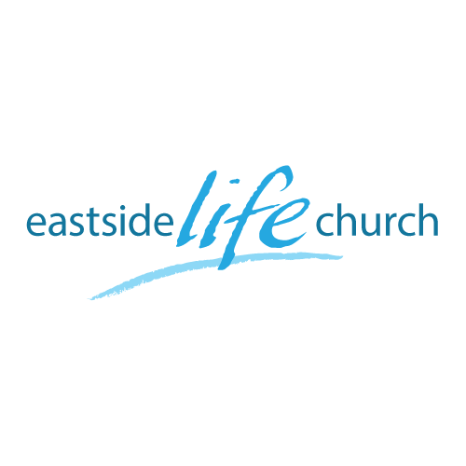
December 9th 2018

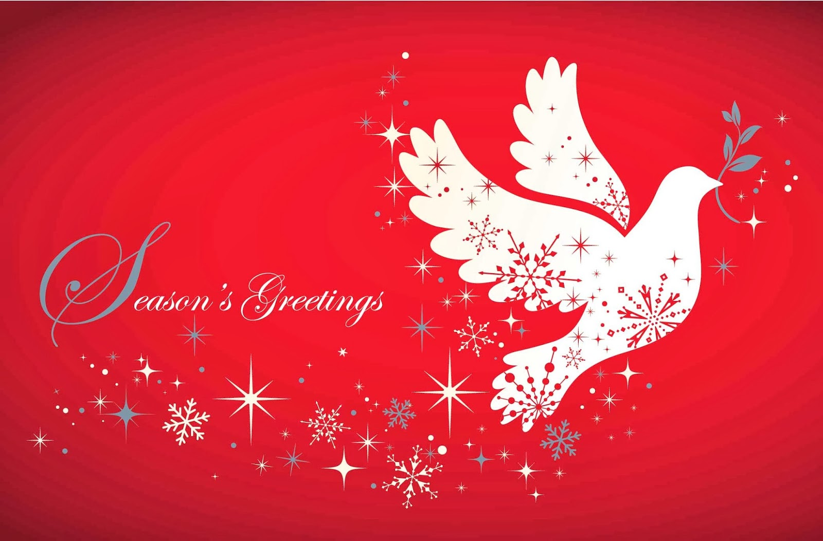

The Spirit of Christmas - 2
“The Spirit of Wisdom”

Welcome
The first Sunday of the Rest (Best) of your life

2018

The Spirit of Christmas– Part 2
“The Spirit of Wisdom”

Matthew 2:1-2
Now after Jesus was born in Bethlehem of Judea in the days of Herod the king, behold, wise men from the East came to Jerusalem, ² saying, “Where is He who has been born King of the Jews? For we have seen His star in the East and have come to worship Him.”

The Kings (Magi) from the East

- 3 Gifts
- Daniel’s connection
- Creation speaks

King Herod: Matthew 2:7
Herod fakes interest in the birth.
His religious advisors quote ancient prophecy:
Micah 5:2

Perspective always comes from God’s Word
The enemy uses the Word of God against you in whatever way.

What gift is worthy enough?

Gifts given in worshipful response to God’s gift to us
Gold – Deity (kingship)
Frankincense – Priestly prayers
Myrrh – Suffering (human)
They were all valuable gifts – worthy of a king!

God is here to help us make wise decisions

- Ask for wisdom: James 1:5
- Be filled with His Word: Psalm 119:105
- Be conscious of your thought patterns: Romans 12:2
Wisdom from ‘above’…Vs from ‘below’
James 3:13-18

Joseph hears from God (and makes wise choices)

Matthew 1:18-21 & Matthew 2:13-14

Final take Away & Communion
The “Spirit of Christmas”

By His Holy Spirit…
(who gives a higher perspective)
…God is “at hand”
to help us make wise choices.

? What is this?

I saw Mommy Kissing Santa Claus
Silent Night
The First Noel
Chestnuts Roasting on an open fire.

