Notes

Men’s Breakfast – Next Saturday Jan 19th @ 8am

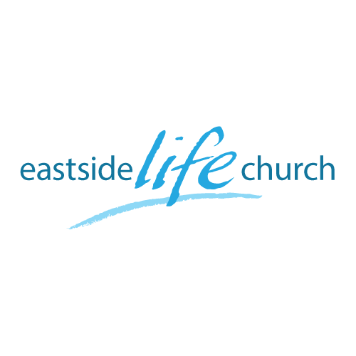
January 13th. 2019

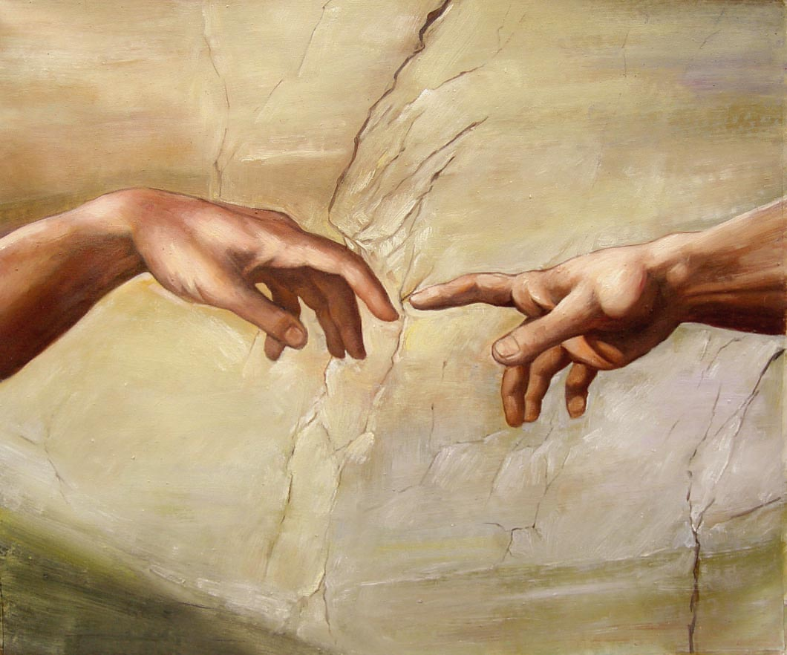

The Touch of God - 2
“Man of Miracles”

Welcome
The first Sunday of the Rest (Best) of your life

2019

The Touch of God– Part 2
“Man of Miracles”

John 2:1-11
¹¹ This beginning of signs Jesus did in Cana of Galilee, and manifested His glory; and His disciples believed in Him.

Jesus anointed by the Holy Spirit

Luke 4:16-18,21
¹⁶ So He came to Nazareth, where He had been brought up. And as His custom was, He went into the synagogue on the Sabbath day, and stood up to read. ¹⁷ And He was handed the book of the prophet Isaiah. And when He had opened the book, He found the place where it was written:
¹⁸ “The Spirit of the Lord is upon Me,
Because He has anointed Me…

Matthew 13:54-56
⁵⁴ When He had come to His own country, He taught them in their synagogue, so that they were astonished and said,
“Where did this Man get this wisdom and these mighty works?

Acts 10:38
³⁸ how God anointed Jesus of Nazareth with the Holy Spirit and with power, who went about doing good and healing all who were oppressed by the devil, for God was with Him.

Water into Wine

- ‘Jesus endorses marriage between
a man and woman.
- 6 empty stone water pots: symbolize man’s ‘vessel of clay’
Filled with water: or ‘the Word’. (120-150 gallons)

- Water into wine: the complimentary work of the Holy Spirit
Joy from wine / Joy from the Holy Spirit.
- This was the beginning of Jesus miracles / signs.
(Moses turned water into blood).

Final take Away & Communion

This Covenant Meal Is a celebration.

The basis of our fellowship with God is the completed work of Jesus on the cross.

It is therefore proper to worship God with Thanksgiving
at Communion time.

