Notes:

January 20th 2019

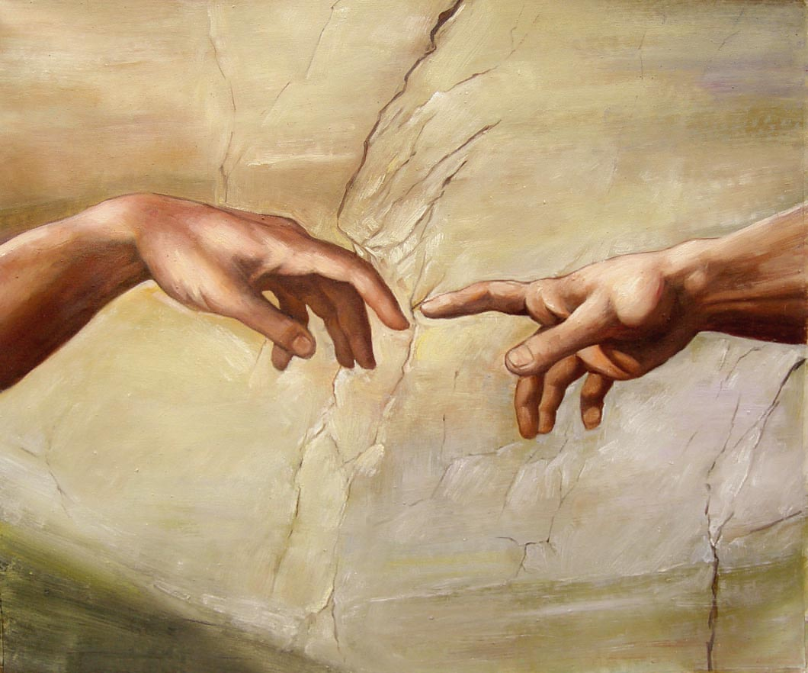

The Touch of God - 3
“God wants to heal you”

Welcome
The first Sunday of the Rest (Best) of your life

2019

The Touch of God– Part 3
“God wants to heal you”

Matthew 8:1-3
When He had come down from the mountain, great multitudes followed Him. ² And behold, a leper came and worshiped Him, saying, “Lord, if You are willing, You can make me clean.”
³ Then Jesus put out His hand and touched him, saying, “I am willing; be cleansed.” Immediately his leprosy was cleansed.

The Foundation

God initiated the plan of restoration for all mankind.
Spirit – Soul – Body
God has made up His mind about us.
The ‘ball’ is still rolling.
The root issue of sin is broken!
How does this plan apply to me right now?
Have I made up my mind?

Jesus cleanses / touches the leper
And reveals His heart

God is instantly ready to ‘touch’ leprous things.
(things affected by the Fall)
His power (or anointing) destroys any ‘oppression’ or ‘yoke’
Acts 10:38

What moves God’s hand?

First,
We do not have to somehow overcome His reluctance to heal us. (Through some spiritual or other practice.)
Being sick qualifies you for healing!
Psalm 84:11

Second,
He was moved with compassion – it was His ‘gut’ response.
Mark 1:41

Healing was built into what He was anointed to do.
Isaiah 61:1-3
He couldn’t help it!! – His default position is to heal.
He made room for healing as a significant part of what He did.
Matthew 4:23-24

Third,
‘Hearing’ plays a significant role in Jesus miracles.
Romans 10:17

Examples of where the people ‘had heard’ and then come to Jesus who then healed them

Mark 5: 25-29 – The woman with the issue of blood.

Mark 2:1-3 – The men who carried the paralytic and lowered him through the roof.

Final take Away & Communion

Galatians 3:5
⁵ Therefore He who supplies the Spirit to you and works miracles among you, does He do it by the works of the law, or by the hearing of faith?

Faith is our response to God’s goodness
The communion tells us the work is complete
All that’s left for us to do is believe and receive.

