Notes:

February 17th 2019

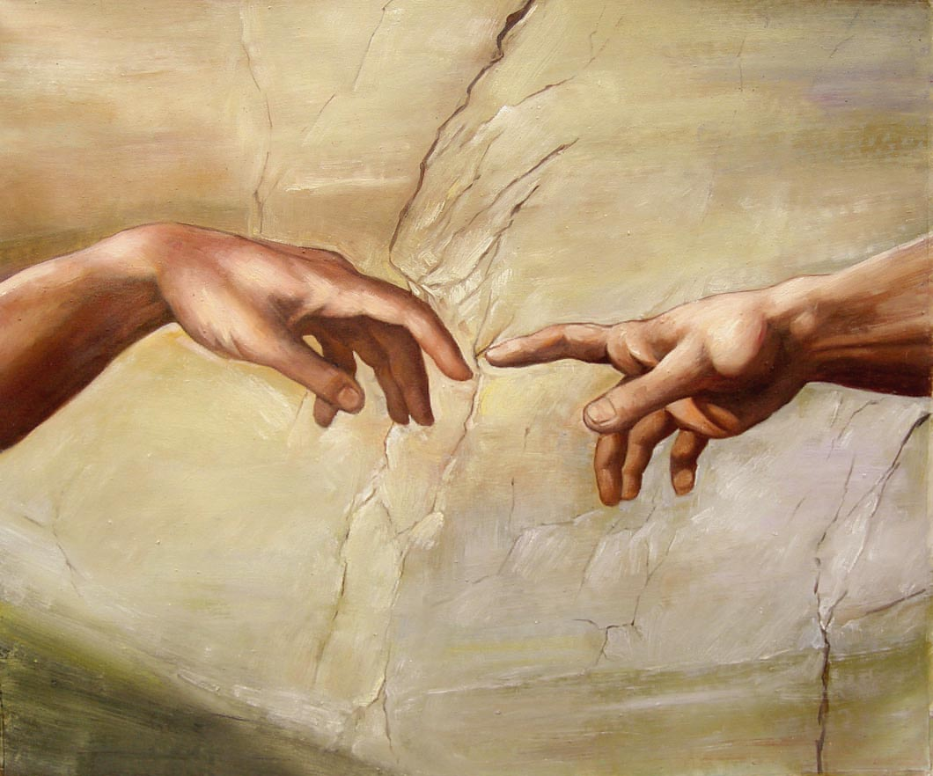

The Touch of God - 6
“There’s power in the name of Jesus”

Welcome
The first Sunday of the Rest (Best) of your life

2019

The Touch of God– Part 6
“Power in the Name of Jesus”

Mark 16:15-18
¹⁵ And He said to them, “Go into all the world and preach the gospel to every creature.
¹⁶ He who believes and is baptized will be saved; but he who does not believe will be condemned.
¹⁷ And these signs will follow those who believe: In My name they will cast out demons; they will speak with new tongues;
¹⁸ they will take up serpents; and if they drink anything deadly, it will by no means hurt them; they will lay hands on the sick, and they will recover.”

“Power of attorney”

Jesus gave the disciples permission and power… and then they went out and followed through. Luke 9:1 / Luke 10:1,17

Persecution for doing something good!?
Later, Peter and John get into trouble for healing

Acts 4:1,8-10
Now as they spoke to the people, the priests, the captain of the temple, and the Sadducees came upon them, ² being greatly disturbed that they taught the people and preached in Jesus (name) the resurrection from the dead.

The “religious reaction” - Acts 4:16-18
…

¹⁸ So they called them and commanded them not to speak at all nor teach in the name of Jesus.

Peter’s reaction to this intimidation

Acts 4:29,33
²⁹ Now, Lord, look on their threats, and grant to Your servants that with all boldness they may speak Your word, ³⁰ by stretching out Your hand to heal, and that signs and wonders may be done through the name of Your holy Servant Jesus.”

Somewhere in the shadow (s)

Acts 5:14-16
¹⁴ And believers were increasingly added to the Lord, multitudes of both men and women, ¹⁵ so that they brought the sick out into the streets and laid them on beds and couches, that at least the shadow of Peter passing by might fall on some of them.

Great grace … great power

What about today?

Healing testimonies via video.

Final Take Away & Communion

Acts 4:29
²⁹ Now, Lord, … grant to Your servants that with all boldness they may speak Your word, ³⁰ by stretching out Your hand to heal, and that signs and wonders may be done through the name of Your holy Servant Jesus.”

There is great power in the name of Jesus who touches us
with His love & healing to break every chain

