Notes:

February 24th 2019

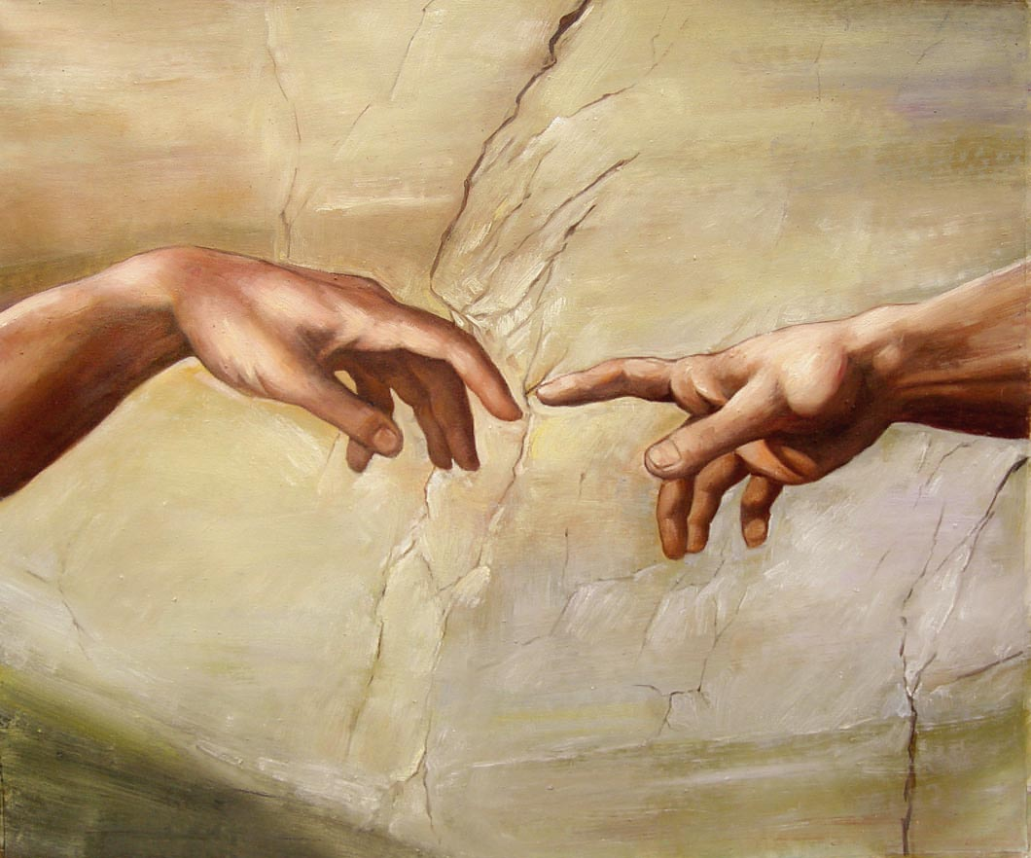

The Touch of God - 7
“The Point of Contact”

Welcome
The first Sunday of the Rest (Best) of your life

2019

The Touch of God– Part 7
“The Point of Contact”

Mark 5:25-34 – The woman with the issue

“Jesus touches Peter’s Mother - in - law”

Matthew 8: 14-18
¹⁴ Now when Jesus had come into Peter’s house, He saw his wife’s mother lying sick with a fever. ¹⁵ So He touched her hand, and the fever left her. And she arose and served them.

Worship & the ‘Healing anointing’
One way we touch God’s heart

Psalm 22:3 (KJV)
³ But thou art holy, O thou that inhabitest the praises of Israel.
One of God’s names (which always describe a facet of His nature & will) is ‘Jehovah Rapha’ – the Lord who heals, cures, restores
The Healer is the one who inhabits our praises.

As we draw near in worship, healing ‘spills out & over us’
Contact is made.

Put it this way

- Our praise attracts God’s manifest presence …
‘The healer’ is there (here) to heal.

Psalm 97:5
⁵ The mountains melt like wax at the presence of the Lord,

- Our praise is a form of ‘spiritual warfare’.

God & the devil don’t share the same space!!
- Praise provides a point of contact

Final Take Away & Communion
My part in Communion

Numbers 21:9
And Moses made a serpent of brass,
and set it upon the pole; and it came to pass,
that if a serpent had bitten any man,
when he looked unto the serpent of brass,
he lived (recovered).
Brass serpent represents the sin (poisoning)
Mere looking – faith in what God has done @ the cross (already)…that’s my part.

