Notes:

April 7th. 2019

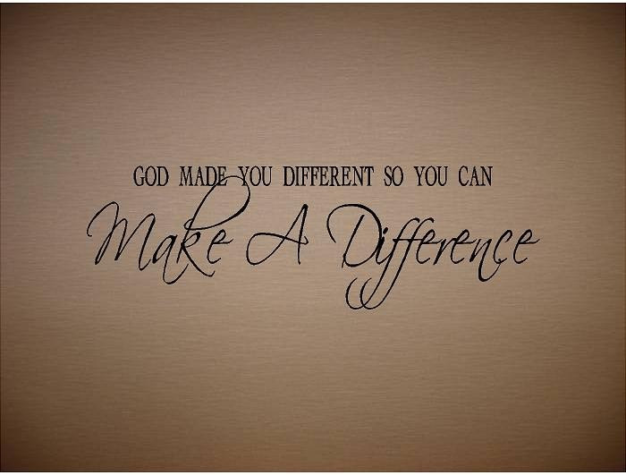

What difference does it make? Part - 5
“Love”

Welcome
The first Sunday of the Rest (Best) of your life

2019

What difference does it make– Part 5
“Love”

1 Corinthians 13:13
And now abide faith, hope, love, these three;
but the greatest of these is love.

Is love all we need?

How to tell whether our relationship with God is ‘love based’?

1 John 4:19
We love Him because He first loved us.

From duty to delight
Or
From delight to duty?

Our obedience is a product of an abiding love relationship.
(It springs from a new heart)

2 Peter 1:2-4

We partake and receive God’s capacity to love.

Remember it’s all in the ‘genes’

Titus 3:5
not by works of righteousness which we have done, but according to His mercy He saved us, through the washing of regeneration and renewing of the Holy Spirit,…

God pours His love into us at the new birth

Romans 5:5
Now hope does not disappoint, because the love of God has been poured out in our hearts by the Holy Spirit who was given to us.

Revelation to our hearts and renewal to our minds.

‘Know about’ vs ‘know’

John 3:3
Jesus answered and said to him, “Most assuredly, I say to you, unless one is born again, he cannot see the kingdom of God.”
- Nicodemus had scriptural knowledge about God, but still needed to know God personally or experientially.
John 17:3
And this is eternal life, that they may know You, the only true God, and Jesus Christ whom You have sent.
- To ‘know’ is to experience intimacy.

Prayer sure helps to grow in love: Ephesians 3:14-19

Final Take Away & Communion

We are more than conquerors in difficult situations.

Romans 8:35-39
Who shall separate us from the love of Christ? (for us) Shall tribulation, or distress, or persecution, or famine, or nakedness, or peril, or sword?
³⁷ Yet in all these things we are more than conquerors through Him who loved us.

