Notes

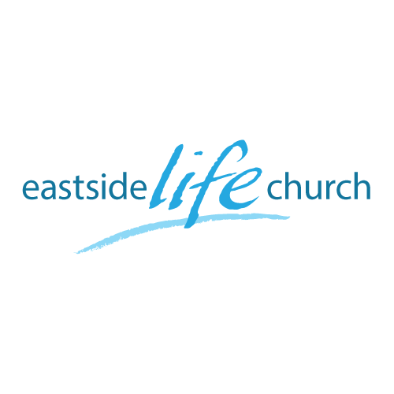
April 16, 2017

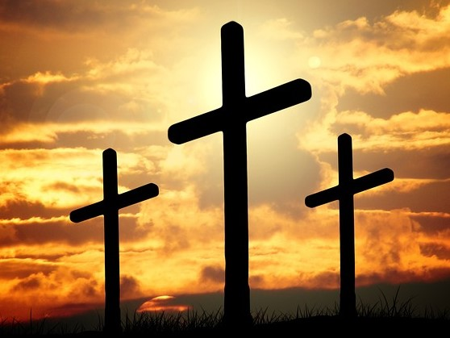

Easter 2017

Welcome

Easter
(Connect the dots)

Making sense of it all - at least some of it today

God’s plan began in God’s heart before the world began:

Revelation13:8b
…the Lamb slain from the foundation of the world.

- Adam & Eve clothed with animal skin.

- Enter Abraham and His supernaturally produced son Isaac.

- Enter Moses, the Passover and the tabernacle in the wilderness.

- Then Jesus with His blood shed on the cross as our substitute.

- Jesus resurrection capped it all off.

His body broken for our healing

His blood shed for our forgiveness.

Hebrew 9:22b
…without shedding of blood there is no remission (of sins)

Upcoming Events

Sunday April 23rd

“Relief Factor” - New Sunday Series

Does God really care about the cares and worries of my life?

Sunday April 30th

“Super Sunday & Brunch” – food & fellowship after service.

Surprise for the kids too.

Tuesdays May 9th – May 30th :

“Christ the Healer” 4 week Lecture Series @ 7- 8:30 pm

Friday May 19th

“Maddexband” – Youth Concert @ 7pm here.

