Notes

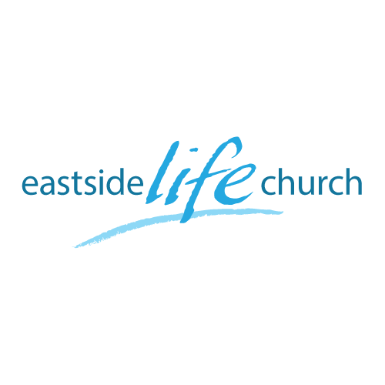
May 21, 2017

Love Life &
See Good Days
Part 1
“Words have consequences”

Welcome
Love Life & See Good Days
(Part 1: Words have consequences)

1 Peter 3:10
“He who would love life
And see good days,
Let him refrain his tongue from evil,
And his lips from speaking deceit.
(Peter Quoting OT Psalm 34:12)

- ‘Evil’ – depraved, immoral, dishonorable,

- ‘Deceit’ – talk that at it’s heart is disconnected from reality, presenting a false reality, distortion, pretense.

- Good ‘days’ – plural: the default mode for believers is good days, not evil ‘days’.

-Ephesians 6:13 teaches us that God gives us His armor to withstand in the evil ‘day’ – singular: that is the default mode is not

- Biblically, Freedom of speech…?

Words have consequences…always.

- Words are not cheap…
-Humans are unique in the creative power (for good or evil) of words.

-The very world was spoken into existence by God and He has called us to use our words to define & create our future as His sons. (Participation)

- Our very ‘salvation’ is dependent on speaking what we believe: Romans 10:9-10

- This is based on what God has (sovereignly) set in motion at the cross, and our faith response. 2 Corinthians 4:13

Spirit or ‘essence’ of faith is to speak what you believe…
And not
What you see with the ‘natural eye’… circumstances.

In our space time continuum things do not always happen instantaneously, so we have this explanation of the dynamics of faith: Mark 11:22-25

If we are to break into fruitful maturity and not stay stuck in a yo-yo existence of inconsistent Christian experience, we have to lay a solid foundation of faith toward God in our daily walk and speech. Hebrews 6:1-2

Final Take Away & Communion
Table Talk

- The context: relationships. 1 Peter 3:8-10

Speak blessing over one another & be like your Father in heaven.

