Notes

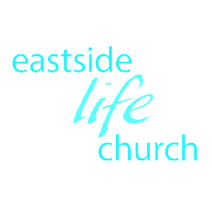

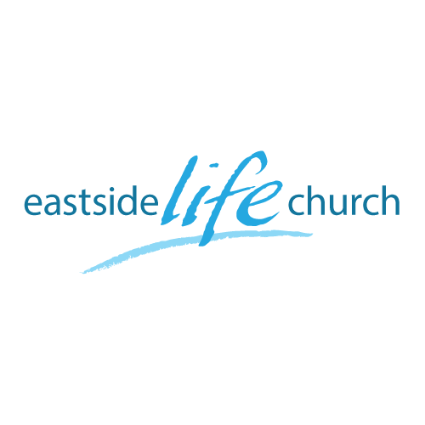

Dec 31st, 2017

New Year’s Eve
More in Store

Part 1
“What makes God happy”

Welcome

More in Store – Part 1
“What makes God happy”

Can we say with confidence that…
…He’s already happy and in a good mood.
Or
Do we have to tread really carefully so as not to upset Him in the year to come?
Let’s settle where the truth lies today.

Foundational tone 2018: Righteousness, peace & joy

Romans 14:17

Live in the ‘light’ (or revelation) of:

- Christ’s righteousness in you: Romans 5:17
- . The peace of Christ will act as an umpire in 2018
John 14:27 / Romans 5:12
- Joy that lubricates everything: Romans 15:13

2018 can be characterized by:

Resting and Receiving Vs Struggling & Striving

The choice is up to us.

Final Take Away & Communion

Luke 12:32
Don't be afraid, little flock, for it is your Father's good pleasure to give you the Kingdom.

Communion is a celebration of the grace we enjoy through faith in
Christ’s completed work

