Notes

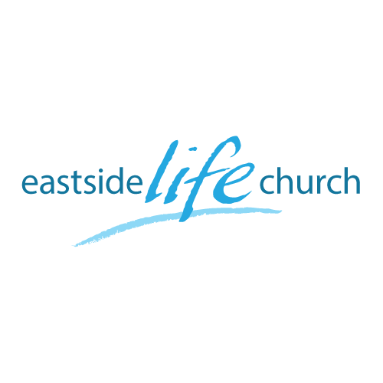
March 11th 2018

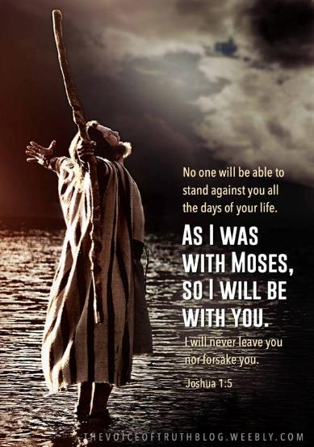

Possess the Land - 1

Welcome

Possess the Land - 1
The Back story

Why do we have all the OT stories?

1 Corinthians 10:11
Now all these things happened to them as examples, and they were written for our admonition, upon whom the ends of the ages have come.

- They show us how to live in the light of Christ’s victory

The Back Story to the “Promised Land” focus:

Israelites had a ‘land’ promised to them under Abraham.
During a famine time, went to Egypt for help, & stayed for 430 years
Became ‘slaves’ after Joseph’s time.
Moses (Charlton Heston) was called to lead them out back to the land.
At first, balked at entering in & thus…
…landed up wandering in the wilderness for 40 years.
Moses died, and Joshua was to lead them in across the Jordan @ Jericho.

We’re coming up to “Easter”
(Jewish Passover ‘Matzos’ and all that)

Exodus 12:24 – the first born was to be “passed over” & spared

The rules associated with the law were not God’s best! – (Relationship was)

Exodus 19:3-6
A kingdom of priests and a holy nation who draws near!

God still wants us to be a kingdom of priests and a holy nation in Christ
Revelation 1: 5b -6
To Him who loved us and washed us from our sins in His own blood, ⁶ and has made us kings and priests to His God and Father, to Him be glory and dominion forever and ever. Amen.

The two “crossings” (Red Sea / Jordan River)

Red Sea under Moses:
Miraculously taken out from Egyptian slavery (type of sin) across the Red Sea.
(The delay of 40 years was because of unbelief).
Speaks of the “Cross” – what Jesus did in breaking the back of sin.

Jordan River under Joshua:
Now they were to enter into the ‘promised land’ by crossing the Jordan.
A land that ‘already belonged’ to them by faith.
Speaks of the resurrection life “in” Christ revealed to us by the Holy Spirit.

Today:
We ‘possess the our promised ‘land’, not by performing a set of works …
…but by faith that comes as a consequence of revelation or light.
Coming to know what belongs to you (already) in Christ
and acting on it.

Final Take Away & Communion

What Jesus did at the cross delivered us from the slavery of:
Sin
Sickness
Lack
Now with the help of the Holy Spirit we are encouraged
to possess (receive) the ‘promised land’.

