ELC
Convergence – Part 1
What in the world is going on?

1 Chronicles 12:32
of the sons of Issachar who had understanding of the times, to know what Israel ought to do

The Bible speaks of ___________times that will come: are we thee now?

2 Timothy 3:1-5
But know this, that in the last days perilous times will come: 2 For men will be lovers of themselves, lovers of money, boasters, proud, blasphemers, disobedient to parents, unthankful, unholy, 3 unloving, unforgiving, slanderers, without self-control, brutal, despisers of good, 4 traitors, headstrong, haughty, lovers of pleasure rather than lovers of God, 5 having a form of godliness but denying its power.

How can I stay stable in unstable times?
1. ‘Understand the times’

2. ’Know what to do’

a) Jesus’ ___________.

Matthew 7:24-25
“Therefore whoever hears these sayings of Mine, and does them, I will liken him to a wise man who built his house on the rock: 25 and the rain descended, the floods came, and the winds blew and beat on that house; and it did not fall, for it was founded on the rock.

b) Provide for you _______________ of your enemies.

Psalm 23:1,5a
The Lord is my shepherd;
I shall not want.
You prepare a table before me in the presence of my enemies;

c) Give you the peace you need.
John 14:27
Peace I leave with you, My peace I give to you; not as the world gives do I give to you. Let not your heart be troubled, neither let it be afraid.

- Final Word:
- Prophecy is not just academic: believers are encouraged to practically:

1. Eagerly await Christ’s _______________.
Titus 2:13
…looking for the blessed hope and glorious appearing of our great God and Savior Jesus Christ,

2. Live ______ lives .
2 Peter 3:10-11
10 But the day of the Lord will come as a thief in the night, in which the heavens will pass away with a great noise, and the elements will melt with fervent heat; both the earth and the works that are in it will be burned up. 11 Therefore, since all these things will be dissolved, what manner of persons ought you to be in holy conduct and godliness.

Notes:

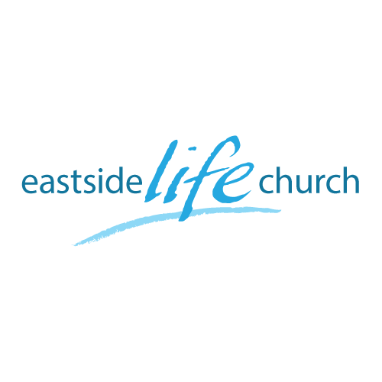

ELC
Convergence – Part 1
What in the world is going on?

1 Chronicles 12:32
of the sons of Issachar who had understanding of the times, to know what Israel ought to do

The Bible speaks of ___________times that will come: are we thee now?

2 Timothy 3:1-5
But know this, that in the last days perilous times will come: 2 For men will be lovers of themselves, lovers of money, boasters, proud, blasphemers, disobedient to parents, unthankful, unholy, 3 unloving, unforgiving, slanderers, without self-control, brutal, despisers of good, 4 traitors, headstrong, haughty, lovers of pleasure rather than lovers of God, 5 having a form of godliness but denying its power.

How can I stay stable in unstable times?
1. ‘Understand the times’

2. ’Know what to do’

a) Jesus’ ___________.

Matthew 7:24-25
“Therefore whoever hears these sayings of Mine, and does them, I will liken him to a wise man who built his house on the rock: 25 and the rain descended, the floods came, and the winds blew and beat on that house; and it did not fall, for it was founded on the rock.

b) Provide for you _______________ of your enemies.

Psalm 23:1,5a
The Lord is my shepherd;
I shall not want.
You prepare a table before me in the presence of my enemies;

c) Give you the peace you need.
John 14:27
Peace I leave with you, My peace I give to you; not as the world gives do I give to you. Let not your heart be troubled, neither let it be afraid.

- Final Word:
- Prophecy is not just academic: believers are encouraged to practically:

1. Eagerly await Christ’s _______________.
Titus 2:13
…looking for the blessed hope and glorious appearing of our great God and Savior Jesus Christ,

2. Live ______ lives .
2 Peter 3:10-11
10 But the day of the Lord will come as a thief in the night, in which the heavens will pass away with a great noise, and the elements will melt with fervent heat; both the earth and the works that are in it will be burned up. 11 Therefore, since all these things will be dissolved, what manner of persons ought you to be in holy conduct and godliness.

Notes:

