ELC
Convergence – Part 2
What in the world is going on?

1 Chronicles 12:32
of the sons of Issachar who had understanding of the times, to know what Israel ought to do

Convergence:
- The frequency and intensity of socio-economic / spiritual & even natural forces paints a picture of convergence. (birth pangs). Matthew 24:1-8
- Even though knowledge has increased it’s the ___________of God that counts the most.
- Keep your _________ fixed on Jesus. Isaiah 26:3
- Awake to new creation realities. 1 Peter 2:9

There’s a ‘Whole lotta shakin’ going on! - Hebrews 12:25-29

God is still in the ‘business’ of saving sinners (grace) – Romans 5:20

‘Making the Most of the Bible’ - Tip 3
- The big picture … where we fit in. – Daniel 2:31-35,44
- The ________________ have sought to have world dominion.

Final Word:
- God’s kingdom (characterized by righteousness, peace & joy) is swallowing up the others. - Revelation 11:15

Then the seventh angel sounded: And there were loud voices in heaven, saying, “The kingdoms of this world have become the kingdoms of our Lord and of His Christ, and He shall reign forever and ever!”

- Rise to the Father’s plan for you in the midst of difficulties:

Isaiah 60:1-2
Arise, shine;
For your light has come!
And the glory of the Lord is risen upon you.
For behold, the darkness shall cover the earth,
And deep darkness the people;
But the Lord will arise over you,
And His glory will be seen upon you.

Resources:

Where To Turn When…
The Book of Psalms is the Bible’s collection of inspiring and comforting poetry. It is written by people who had the same feelings as you, yet overcame with God’s help. The Psalms express the heartfelt realities of life’s struggles, challenges and triumphs…. But not without God’s promises to help and encourage you.

Use the following selection when…

- You need guidance and counsel. Psalm 1

- You feel abandoned. Psalm 10

- You don’t know what God expects. Psalm 15

- You are afraid and need comfort. Psalm 23

- You see others (the wicked) prosper. Psalm 37

- You want to know God better. Psalm 42

- You faith seems to be slipping. Psalm 62

- You can’t see how being true to God helps. Psalm 90

- You feel threatened and in danger. Psalm 91

- You want to celebrate God’s goodness. Psalm 95–100

- You need reminding of God’s goodness. Psalm 103

- You feel unthankful. Psalm 107

- You need wisdom. Psalm 119

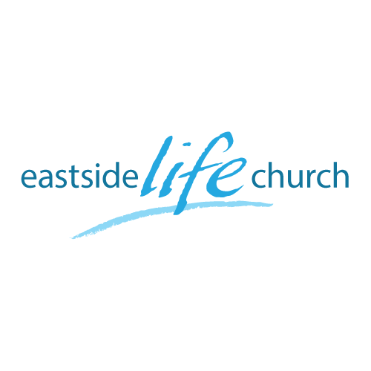
ELC
Convergence – Part 2
What in the world is going on?

1 Chronicles 12:32
of the sons of Issachar who had understanding of the times, to know what Israel ought to do

Convergence:
- The frequency and intensity of socio-economic / spiritual & even natural forces paints a picture of convergence. (birth pangs). Matthew 24:1-8
- Even though knowledge has increased it’s the ___________of God that counts the most.
- Keep your _________ fixed on Jesus. Isaiah 26:3
- Awake to new creation realities. 1 Peter 2:9

There’s a ‘Whole lotta shakin’ going on! - Hebrews 12:25-29

God is still in the ‘business’ of saving sinners (grace) – Romans 5:20

‘Making the Most of the Bible’ - Tip 3
- The big picture … where we fit in. – Daniel 2:31-35,44
- The ________________ have sought to have world dominion.

Final Word:
- God’s kingdom (characterized by righteousness, peace & joy) is swallowing up the others. - Revelation 11:15

Then the seventh angel sounded: And there were loud voices in heaven, saying, “The kingdoms of this world have become the kingdoms of our Lord and of His Christ, and He shall reign forever and ever!”

- Rise to the Father’s plan for you in the midst of difficulties:

Isaiah 60:1-2
Arise, shine;
For your light has come!
And the glory of the Lord is risen upon you.
For behold, the darkness shall cover the earth,
And deep darkness the people;
But the Lord will arise over you,
And His glory will be seen upon you.

Resources:

Where To Turn When…
The Book of Psalms is the Bible’s collection of inspiring and comforting poetry. It is written by people who had the same feelings as you, yet overcame with God’s help. The Psalms express the heartfelt realities of life’s struggles, challenges and triumphs…. But not without God’s promises to help and encourage you.

Use the following selection when…

- You need guidance and counsel. Psalm 1

- You feel abandoned. Psalm 10

- You don’t know what God expects. Psalm 15

- You are afraid and need comfort. Psalm 23

- You see others (the wicked) prosper. Psalm 37

- You want to know God better. Psalm 42

- You faith seems to be slipping. Psalm 62

- You can’t see how being true to God helps. Psalm 90

- You feel threatened and in danger. Psalm 91

- You want to celebrate God’s goodness. Psalm 95–100

- You need reminding of God’s goodness. Psalm 103

- You feel unthankful. Psalm 107

- You need wisdom. Psalm 119

