Eastside Life Church
Easter 2016
Simeon’s Moment
Luke 2:25,28
There was a man named Simeon…
…who took Jesus up in His arms

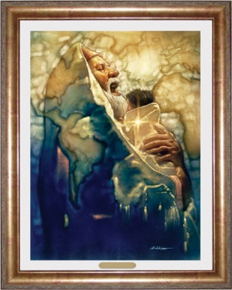

The Last Passover Supper
Matthew 26:19-20
So the disciples did as Jesus had directed them;
and they prepared the Passover.
When evening had come, He sat down with the twelve.

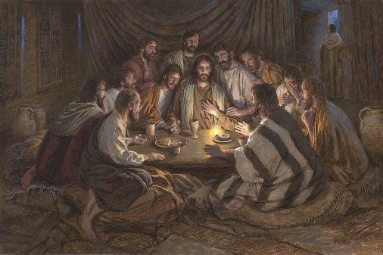

Jesus is crucified
Luke 23:33
And when they had come to the place called Calvary, there they crucified Him, and the criminals,
one on the right hand and the other on the left.

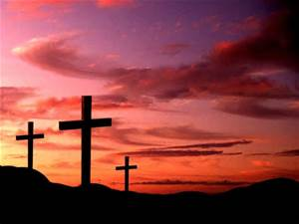

The Empty Tomb
Matthew 28:6
He is not here, for He is risen, just as He said.
Come see the place where the Lord lay.

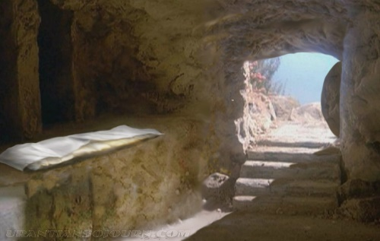

Notes:

New Series starting next week:
‘Open Heaven / River Wild’
The Person & Work of the Holy Spirit
www.eastsidelifechurch.org

Eastside Life Church

Easter 2016

Welcome

John 10:10
“I am come that they might have life,
and that they might have it more abundantly.”

