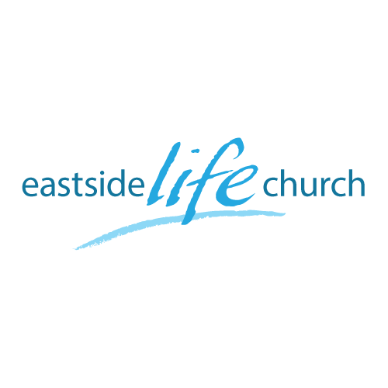
April 3, 2016

Open Heaven River Wild – Part 2

- We are to grow in relating to the Holy Spirit as a divine person.

- The HS comes to us, works in and then through us.

- Well - John 4:13 (for our benefit)
- __________ – John 7:38-39 (for other’s benefit)

John 15:5-11 – Our Divine Advantage

- The Holy Spirit as our helper:

- Our helper in worship: John 4:23

- Our helper in our walk: Romans 8:26 / John 16:13

- Our witness: John 16:8-11

- The Holy Spirit’s_____________ presence:

(Psalm 51:10-11 / John 14:18)

Final Word

- Become God __________ minded

- Abiding presence: not due to our righteousness, but _____________ righteousness.

Notes

