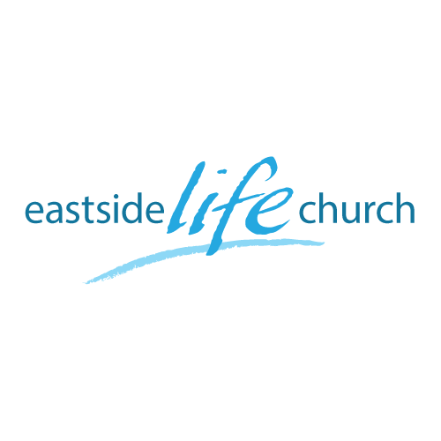
April 24, 2016

Open Heaven River Wild – Part 4
The gateway to the Miraculous

The plan, purpose, power and people of God

- Jesus anointed by the HS after heavens opened to Him.
- Helps us in worship, walk and witness: divine deposit.
- After His resurrection, He ‘breathed’ on the disciples.
John 20:21-22
- Then opens up this ministry to all believers:
Mark 16:15-21 / Acts 1:8 / Acts 2:1-4

The Gateway to the Miraculous is now open to all believers.

Acts 3:4-7 - (Peter & John at the Gate beautiful)

Acts 8:14 - 17 - (Again with Peter & John)

Acts 10:44 – (With Peter at Roman Centurion)

Acts 19:1-6 – (With Paul at Ephesus)

Note the pattern / connect the dots:
- The Word goes out / Laying on of hands
- Water baptism / Tongues / Not just apostles / No mention of interpretation here.

Avoiding confusion:
- Every believer has the Holy Spirit within.
- The baptism or immersion may be described as another manifestation.
- Devotional tongues & ministry Gift with interpretation.

Power to Redeem - By Lauren Daigle
You take what is
And you make it beautiful
When love floods in
We're resorted forever more

With breath that brings the dead to life
With words that pierce the dark with light
Only by the blood are we set free.
With mercy strong to carry shame
And nail it to a tree You alone
Hold the power to redeem.

No guilt competes
With innocence crucified
No grave can hold what your grace has justified
With breath that brings the dead to life
With words that pierce the dark with light
Only by the blood are we set free.
With mercy strong to carry shame
And nail it to a tree you alone
Hold the power to redeem

Rejoice oh child of God
Lift your eyes to see
With every morning light
Again we are redeemed (X2)

With breath it brings the dead to life
With words that pierce the dark with light
Only by the blood are we set free.
With mercy strong to carry shame
And nail it to a tree you alone
Hold the power to redeem.

Oh you alone, hold the power to redeem
Oh you alone, hold the power to redeem

