*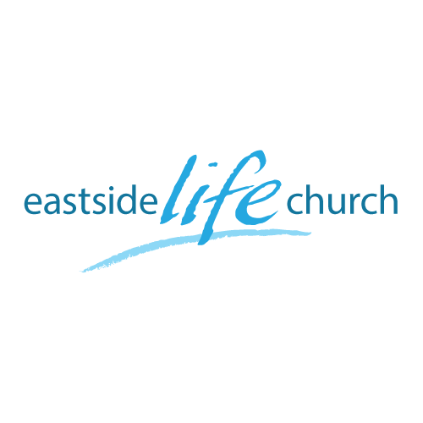***June 12, 2016**

**Promises Made & Promises Kept – Part 4**

*‘Jesus Our Covenant hero’’*

* Jesus at the pinnacle of the covenants: the ‘**scarlet thread.’**

**Hebrews 8:6**

**Where do we fit into the ‘Big Picture’ today? - review**

* God created the world gave us authority over it.
* Man fell, sin entered with all its negative consequences
* God set in motion blood covenants to **redeem** or ‘buy man back’ from **illegal authority** of satan, and **restore** mankind.
* These covenants:

-Allowed parties to exchange strengths & weaknesses.

-Become loyal committed ‘friends’

-Receive a new identity& break from the bad past.

-Involved an **exchange of garments.**

**Isaiah 61:10** - Grace **(***Vs)* **Isaiah 64:6**  - self effort.

**The Great Promise Keeper**

**Genesis 12:1-3**

* Abraham eventually **received** his son Isaac & then required to sacrifice him: what’s yours is mine / what’s mine is yours.

**Genesis 22:1-2**

* Travels 3 days, climbs the Mt. (within sight of Calvary).
* Isaac laden with wood (symbolic of the cross).
* Isaac wants to know ‘what’s up’ (Abraham speaks His faith: God will provide).
* Abraham had become fully convinced: ‘mental assent’ by revelation to ‘faith’.
* Jesus said that Abraham got a **revelation** of him on the cross.

**John 8:56 / Hebrews 11:17-19**

* Abraham is stopped in the act by ‘God who provides’ a ram caught in thorny thicket. (Jesus with crown of thorns).
* Abraham calls the place **‘Jehovah Jireh’** – the covenant God who provides. Jesus: the ‘gateway’ to all God’s provision.
* God restates the covenant blessings highlighting His blessings: (Because ‘he obeyed’).
* Abraham is listed in the ‘Hebrews hall of faith’ getting 11 verses.

**Final take away:**

* Connected to God through covenant: that’s how He operates.
* He makes and keeps His promises over centuries.
* Know, understand, apply and enjoy the New Covenant.
* Jesus our ‘covenant hero’: **better promises**.

**Notes**

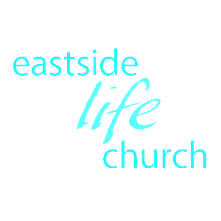

****June 12, 2016**

**Promises Made & Promises Kept – Part 4**

*‘Jesus Our Covenant hero’’*

* Jesus at the pinnacle of the covenants: the ‘**scarlet thread.’**

**Hebrews 8:6**

**Where do we fit into the ‘Big Picture’ today? - review**

* God created the world gave us authority over it.
* Man fell, sin entered with all its negative consequences
* God set in motion blood covenants to **redeem** or ‘buy man back’ from **illegal authority** of satan, and **restore** mankind.
* These covenants:

-Allowed parties to exchange strengths & weaknesses.

-Become loyal committed ‘friends’

-Receive a new identity& break from the bad past.

-Involved an **exchange of garments.**

**Isaiah 61:10** - Grace **(***Vs)* **Isaiah 64:6**  - self effort.

**The Great Promise Keeper**

**Genesis 12:1-3**

* Abraham eventually **received** his son Isaac & then required to sacrifice him: what’s yours is mine / what’s mine is yours.

**Genesis 22:1-2**

* Travels 3 days, climbs the Mt. (within sight of Calvary).
* Isaac laden with wood (symbolic of the cross).
* Isaac wants to know ‘what’s up’ (Abraham speaks His faith: God will provide).
* Abraham had become fully convinced: ‘mental assent’ by revelation to ‘faith’.
* Jesus said that Abraham got a **revelation** of him on the cross.

**John 8:56 / Hebrews 11:17-19**

* Abraham is stopped in the act by ‘God who provides’ a ram caught in thorny thicket. (Jesus with crown of thorns).
* Abraham calls the place **‘Jehovah Jireh’** – the covenant God who provides. Jesus: the ‘gateway’ to all God’s provision.
* God restates the covenant blessings highlighting His blessings: (Because ‘he obeyed’).
* Abraham is listed in the ‘Hebrews hall of faith’ getting 11 verses.

**Final take away:**

* Connected to God through covenant: that’s how He operates.
* He makes and keeps His promises over centuries.
* Know, understand, apply and enjoy the New Covenant.
* Jesus our ‘covenant hero’: **better promises**.

**Notes**

