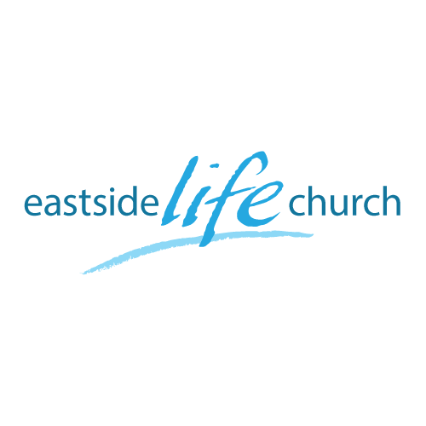
June 19, 2016

Promises Made & Promises Kept – Part 6
‘Jesus our covenant Healer’’

- Since the Fall, not everything is “all good”.
-God is in process of restoring wholeness.
- Jesus is the High priest of the New Covenant in His blood.
-Forgiveness & healing of our bodies.
- The ancient Hebrew mindset of salvation involved the whole person: Spirit, soul & body were to be ‘saved’ / made whole.
Psalm 103:2-3
- Science shows that all three aspects play into each other.

Healing is our inheritance
‘We get what was promised in the will’

- The Last supper was the covenant meal that celebrated 2 key aspects:
-His blood for the forgiveness of sin.
-His stripes for healing of our bodies.
Matthew 26:26-27 / 1 Peter 2:24

- It’s a covenant exchange: what’s yours is mine / what’s mine is yours.
- Agree that Jesus’ work on the cross is the basis of a healthy life.
Jesus heals them all

- Jesus ministered healing under the Old Covenant fulfilling prophecy / promises: Matthew 8:16-17 / Luke 13:16
- What was moving Jesus? (correctness or compassion).

Matthew 14:14
- Did Jesus heal all of them? Luke 4:40

Do you have to be perfect to receive healing?
Was it possible to break the Law and still get healed.

- pNT The leper broke the Law to come to Him. Mark 1:40-42

- Conclusion: The only thing needed to ‘position yourself’ - be in need & come to Jesus.

Final take away:

- Besides laying on of hands, anointing with oil, the prayer of faith, communion too.
- As we discern not only His shed blood, but also His broken body, we ‘position’ ourselves to receive all His covenant benefits we partake in faith. 1 Corinthians 11:23-26

Notes
