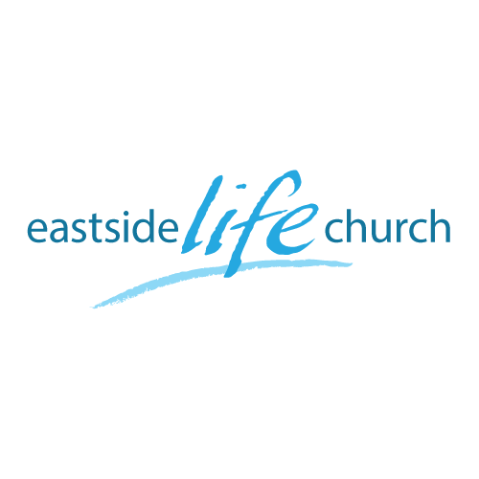
October 23, 2016

What is God really like? – Part 8
God is holy

Holy / Holiness defined: God’s essential nature.
- Many see only some people who do wonderful works as ‘holy’: like the Pope or Mother Teresa
- Yet the Bible definition in both OT & NT: ‘sacred, set apart’.
- For Eg. The Israelites were called to be a ’holy’ people.
Exodus 19:6
-Set apart for various purposes:
To bring forth the Messiah,
To be a witness to the world,
To be conveyers of God’s word.

- Yet their up & down history shows they didn’t always act ‘holy’.
- They were not even chosen because of their inherent holiness / size, goodness or special qualities. Deuteronomy 7:6-7

True vs False holiness:
- True: God centered - what He did on our behalf as His grace gift & how that impacts us
-Inner heart attitudes / postures of humility, meekness
-‘Clothed’ with His robe of righteousness.
Or
- False: Man centered: what we are ‘supposed’ to do to ‘earn’ His favor.
-Focused on performance & externals: Eg. Clothes.
-Clothed with our efforts … which always fall short.

The issue of holiness is tied to what really happened at the cross
- Sin was not only forgiven but also removed from the equation of relationship. Colossians 2:13-14 / 1 John 3:5
- You could say that sin is no longer the issue:
-If so, what then is the issue? (At least in God’s mind.)
- Faith in Christ (His work on our behalf) is what we live by: Romans 2:4

Holiness: from ‘duty’ to ‘delight’:
- Duty is what we are ‘required’ to do:
-Duty: ‘requirement, payment due, obligation’.
- Delight speaks rather about the privilege of living for our loving Father.
-Delight: ‘enjoyment, pleasure, joy.’
- The Prodigal son, his brother, and their dad: Lke 15:11-32
-Neither son really knew the father’s heart even though they both lived with Him for years.
(God will not force a good relationship off on us).
-The younger (prodigal) saw his father as someone to be ‘used’.
-The older saw the father as reluctant to bless task master to be ‘served’.
-Neither showed true respect for the father.
- Devotional aspect from this:
-Read the bible not for information alone but transformation.
- ‘Actions’ performed out of duty or delightful expressions of love: the fruit of holiness.

Final Take Away
How to live in the realm of faith & grace:

Romans 5:17: ‘Receive’ vs ‘work for’ / ‘gift’ vs ‘payment’ for work.
- We live by faith in Christ completed work.
- We are made (recreated) a holy nation, a royal priesthood.
1 Peter 2:9
- Identify with God’s view of who He has made us to be.
- Now that Christ lives in us, we are empowered to live the ‘Spirit filled life’. Romans 8:1-3a
-This is an ‘already done freedom’.
-Christ ‘within’ Vs Law ‘without’.

