Discovery - Topics & Content:
Week 4: Tuesday Nov 1, 2016
Session 4 A: Discovering Why people still read the Bible in the 21st C.
Intro & Review:

- God is masterful in His genius to communicate with mankind:
-Through creation, language, national history, science.
- We looked at four focal points last session:
- The marvel of conception: complexity of design speaks of designer.
- The ‘big bang’ & creation: the search for a first cause.
- Secrets of Hebrew Text: Genesis 1:1 – the Aleph-Tav, creation, Jesus.
- The pattern of sevens in the Bible.

- Interestingly the New Testament also connects creation with Jesus the savior.

John 1:1
In the beginning Was the Word, and the Word was With Elohim, and the Word Was Elohim. 2 The same was in the beginning WITH ELOHIM. 3 All things were made THROUGH HIM; and without Him was not any thing made that was made…14 And the word became flesh and tabernacled among us.

John 1:1 (in the Hebrew Bible) - see picture
בראשית היה הדבר והדבר היה את האלהים ואלהים היה הדבר׃

-Jesus is the Aleph-Tav את at the center of even this NT verse about creation at the beginning.

Give God a Chance
More on Creation

Romans 1:20 For since the creation of the world His invisible attributes are clearly seen, being understood by the things that are made, even His eternal power and Godhead, so that they are without excuse,…
The Light Spectrum (and the Phenomenon of Sevens)
- Sir Isaac Newton - Physicist (1642- 1727) was a very serious Scripture student, proved that visible light was made up of the seven colors of the spectrum that come from the three primary colors.
-Primary colors: blue, green and red.
- The four others come from these three; they are magenta, cyan, yellow and bringing all the colors together, produces the seventh, pure white light.
-Some include indigo as a color, others do not.
- There are also seven forms of light energy: radio waves, microwaves, infrared, visible, ultraviolet, x-rays and gamma rays (see graphic below).
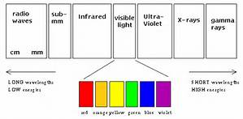
Rainbow with 7 colors:
1 John 1:5 This is the message which we have heard from Him and declare to you, that God is light and in Him is no darkness at all.
Genesis 9:12-13 God and sign of covenant with Noah

The Number Seven in both Old & New Testaments:

- God is the greatest mathematician of all time (Sorry Einstein).
- Basic breakdown:
-Humanity is represented by 4, then add the divine triunity 3 of Father, Son & Holy Spirit = 7
-Mankind is only complete / perfect with God.

Old Testament:
- God created everything and ‘rested’ in 7 days.
- Every seventh year was a sabbatical year of rest.
- There were seven feast days in the Jewish calendar.
- Naaman dipped in the Jordan seven times to be healed.

New Testament:
- Jesus said to forgive 70 X 7: lifestyle.
- Book of Revelation: ‘book of completion’ features:
-Seven letters to seven churches
-Seven aspects of the Spirit of God
-Seven candlesticks,
-Seven stars,
-Seven angels,
-Seven lamps.
More on Jesus, The Aleph-Tav and the Hebrew language

Luke 24:27
And beginning with Moses and all the Prophets, he interpreted to them in all the Scriptures the things concerning himself.

- Genesis 1:1 shows interesting patterns, but are there more elsewhere?
-If you can believe Genesis 1:1, then it’s downhill from there.
- Theologically, the OT portrays Jesus Christ the Messiah as the substitutionary lamb of sacrifice crucified on the cross on our behalf to save us from sin & consequences.

- Moses gave instructions for the sin offering bull (ox) to be sacrificed:
-Leviticus 4:21 And he shall carry the bull outside the camp, and burn (aleph Tav) ‘him’ as he burned the first bull; it is a sin offering for the congregation.
-The priest would ‘lay’ the iniquity of the people on the bull (ox) that would bear it away.

- Prophet Isaiah: (Aleph Tav = Strength of the ox /cross)
Isaiah 53:6 All we like sheep have gone astray; we have turned every one to his own way; and YHVH has laid (Aleph Tav) the iniquity of us all.
(To clarify KJV added the words “on him” where Aleph Tav is).
-NT connection:

1 Peter 2:24 who Himself bore our sins in His own body on the tree, that we, having died to sins, might live for righteousness—by whose stripes you were healed.

- Prophet Zechariah portrays Messiah (the Aleph-Tav) being pierced & mourned:

(KJV inserts ‘Him’- however it’s not there in the Hebrew).

Zechariah 12:10
And I will pour upon the house of David, and upon the inhabitants of Jerusalem, the spirit of grace and of supplications: and they shall look upon (Aleph-Tav) whom they have pierced, and they shall mourn for him, as one mourneth for his only son, and shall be in bitterness for him, as one that is in bitterness for his firstborn.
The placement of Aleph-Tav in connection with names / subject matter:
- Jacob & Esau example: (involves the importance of birthright)
-In Genesis 25:28, both Jacob and Esau have Aleph/Tav את Symbols in front of their names in the beginning of their life together, but the LAST time we see the Aleph/Tav את Symbol used in front of Esau’s name is Genesis 27:1.
-On that day Isaac calls to Esau to ask him to hunt him some savory meat so that he (Isaac) may bless Esau. Even though Esau’s name is used another 78 times in the Torah the Aleph/Tav את Symbol continues to be only in front of Jacob’s name and not Esau’s, because the covenant blessing of the birthright given by Messiah was removed from him.
-The reason Esau has no Aleph/Tav את Symbols in front of his name after Genesis 27:1 is explained by Moses in Genesis 25:34 for so despised Esau his את birthright!
- Ruth’s example: (one for the ladies).
-It’s about how an ‘outsider’ gentile Ruth who gets grafted into God’s people by Boaz her ‘kinsman redeemer’ as per the custom of the day.
-The male relative could step in to redeem a person or property when a relative was in trouble.
-It involves the placement of the Aleph/Tav את Symbols in the Book of Ruth. Ruth’s name is used 12 times in the book. The first 10 times there is no Aleph/Tav את Symbol in front of her name.
-After she is redeemed by Boaz the next two times her name is used an Aleph/Tav את symbol is in front of her name each time.
-The Aleph/Tav את Symbol shows a connection of “covenant” relationship regarding the God-head.
Concluding Thoughts:
- The statistical chances of ancient scribes colluding to come up with the above patterns is highly unlikely.

- God is using His genius to connect dots for whosoever is open to study & learn.

Discovery
Week 4: Tuesday Nov 1, 2016
Session 4 B: Discovering who Jesus really was (& is)
- God is continually setting us up to consider Jesus His Son as central.

- His MO was to establish a series of covenants which must be rightly divided.
-Jesus came in fulfilment of covenant.

- Key division is between OT & NT: Law & Grace.
-Grace in the person of Jesus fulfilled the Law on our behalf.
-Righteousness is passed on to us through faith in His completed work.

Quick note about interpreting the Bible:
- ‘Eisegesis’ is where you ‘read into the text’ from an already established position.
-More subjective. (Also called deductive approach).

- ‘Exegesis’ is where you ‘draw out’ from the scripture what it is saying.
-More objective. (Also called inductive approach).

Acts 17:10-12 Then the brethren immediately sent Paul and Silas away by night to Berea. When they arrived, they went into the synagogue of the Jews. ¹¹ These were more fair-minded than those in Thessalonica, in that they received the word with all readiness, and searched the Scriptures daily to find out whether these things were so. ¹² Therefore many of them believed, and also not a few of the Greeks, prominent women as well as men.
Jesus in His humanity
Was Jesus fully human?... and what are the implications of this?
If Jesus was fully God, how could God die?
Is the virgin birth that important?

- Christians believe that Jesus was born of a woman, lived and died, and then rose again from the dead.
-How can we be so sure: surely it cannot be blind ‘just so’ faith?
- We have seen in previous sessions that the Bible is a uniquely remarkable library of record that can be trusted to convey truth to the seeker after truth.
-Creation, science, history & personal testimony pt. in the same direction.
- Externally Josephus a Jewish Historian in his Antiquities of the Jews, written around 93–94 AD (nearly 25 years after the first known Gospel, Mark, dated around 70 AD) includes two references to the biblical Jesus Christ in Books 18 and 20 and a reference to John the Baptist in Book 18
-In the Antiquities of the Jews (Book 20, Chapter 9, 1) Josephus refers to the stoning of "James the brother of Jesus" (James the Just) by order of Ananus ben Ananus, a Herodian-era High Priest.
-In the Antiquities of the Jews (Book 18, Chapter 5, 2) Josephus refers to the imprisonment and death of John the Baptist by order of Herod Antipas, the ruler of Galilee and Perea.
-The Testimonium Flavianum (meaning the testimony of Flavius Josephus) is the name given to the passage found in Book 18, Chapter 3, 3 of the Antiquities in which Josephus describes the condemnation and crucifixion of Jesus at the hands of the Roman authorities.
- Luke the physician wrote a Gospel that emphasizes Jesus’ humanity:
-Remember the ‘face of a man’ imagery in Ezekiel 1:10-11 & Rev 4:7-8
-Written to ‘Theophilus’ (friend or lover of God) with a ‘Greek’ cultural mindset that valued human perfection.
-Luke deals largely with eye-witness accounts vs theological commentary.
- Jesus came to be one of us so that full communication could happen.

-He is referred to as the ‘son of man’ 25 X in Luke’s Gospel.

(God relates to us in ways we can comprehend).

-His name ‘Jesus’ (humanity) is emphasized over ‘Christ’ (deity).

- His human entrance: virgin conception & birth is described in detail: Luke 1& 2.

-Not some weird falling from the sky deal like the pagans in Ephesus.

Acts 19:35
After quieting the crowd, the town clerk said, "Men of Ephesus, what man is there after all who does not know that the city of the Ephesians is guardian of the temple of the great Artemis and of the image which fell down from heaven?

- His human genealogy traces back to Adam, not Jewish patriarch Abraham as does Matthew’s genealogy. Luke 3:23-38

-Emphasizes commonality with all mankind:

- His human growth & development is described (would impress the Greeks).

Luke 2:40,51-52 ‘Child grew and became strong in spirit, … 51 Then He went down with them and came to Nazareth, and was subject to them, but His mother kept all these things in her heart. 52 And Jesus increased in wisdom and stature, and in favor with God and men. (Emphasis added)

- His human existence & perfection is noted: physical, intellectual and spiritual.
(Gets hungry & wards off temptation 3X with ‘It is written’.

Luke 4:1-4 Then Jesus, being filled with the Holy Spirit, returned from the Jordan and was led by the Spirit into the wilderness, ² being tempted for forty days by the devil. And in those days He ate nothing, and afterward, when they had ended, He was hungry.
³ And the devil said to Him, “If You are the Son of God, command this stone to become bread.”
⁴ But Jesus answered him, saying, “It is written, ‘Man shall not live by bread alone, but by every word of God.’”

- Jesus identifies with human needs ministering to a variety of outcasts, sick etc

- Luke even emphasizes Jesus prayer life:

Luke 5:16 So He Himself often withdrew into the wilderness and prayed.

-Prayer shows human need and dependence on the divine.

- He even needed strengthening in His humanity by angels at His passion.

Luke 22:43 Then an angel appeared to Him from heaven, strengthening Him.

- He operated out of His full humanity anointed by the Holy Spirit.
Acts 10:38 how God anointed Jesus of Nazareth with the Holy Spirit and with power, who went about doing good and healing all who were oppressed by the devil, for God was with Him.

Concluding thoughts:
- We discover our true and full humanity only when we are saved by Jesus;
Psalm 17:15 As for me, I will see Your face in righteousness;
I shall be satisfied when I awake in Your likeness.

Resources for Sessions 4 A & B
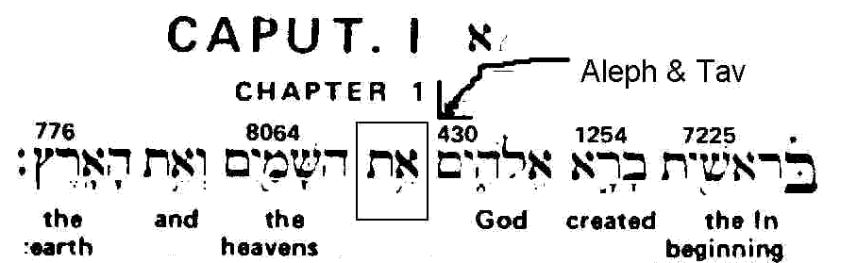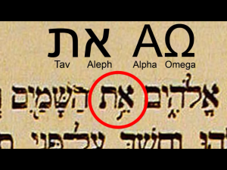

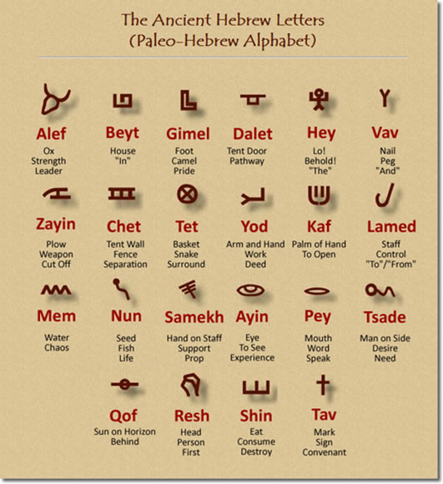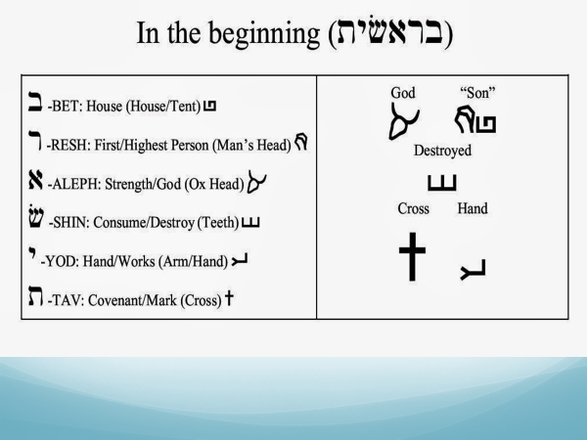
Genesis 1:1 – Hebrew and paleo-pictographs compared with 22 letter alphabet
More on the Aleph Tav:
- https://alephtavscriptures.com/

- Free download: See above website https://alephtavscriptures.com/wpcontent/uploads/2015/01/MessianicAlephTavScripturesMATSPdf.pdf

- http://www.myscripturestudies.com/2009/01/aleph-tav-herald-of-messiah.html

- http://www.fillthevoid.org/Apologetics/number7MikeHoggard.html

Bonus: Secrets of the Hebrew language / The genealogies of Adam to Noah
- The Hebrew language has depths ‘hidden’ for those who will search them out.

- The 10-person genealogy from Adam to Noah in Genesis 5: 1-32 reveals the gospel message as follows:

[Adam] אדמה Mankind’s Genesis 2:19
[Seth] שת appointed Genesis 4:25
[Enos] אנוש mortal Genesis 4:26
[Cainan] קינן sorrow Genesis 5:9
[Mahalaleel] מהללאל but the praise of God Genesis 5:12
[Jared] ירד shall descend Genesis 5:15
[Enoch] חנוך teaching Genesis 5:18
[Methuselah] מתושלח his death shall bring Genesis 5:21
[Lamech] למך powerful Genesis 5:25
[Noah] נח rest, comfort Genesis 5:29

- Genesis 5 Genealogy Summarized in more easily readable English:
“Man has been appointed to mortal sorrow, but the blessed God will come down teaching so that His death will bring to the despairing rest.”
-Chances of a coincidence? Probably Zero.

Numbers in The Bible: ‘Numerics’
Matthew 10:30 But the very hairs of your head are all numbered.
Revelation 13:18 Here is wisdom. Let him who has understanding calculate the number of the beast, for it is the number of a man: His number is 666.
- Bible Numerics must be distinguished from the improper (occultic) practice of ‘numerology’ that is today, often associated with the paranormal alongside astrology and similar divination which is forbidden by God (Deuteronomy 18:9-11). Remember God is the originator of all things good and pure, but the deceiver (satan) perverts or twists all that is good.
- Bible Numerics is the study of numerical patterns in the Bible and the use of numbers to represent certain concepts. Bible Numerics seem to support the authenticity and divine inspiration of Bible passages and should not become something that obscures the clearer revelation of God’s person, nature and will.
- God, who created the universe and all its natural laws, is obviously the mathematician of all time. His natural creation is underpinned by astounding mathematical complexity and elegance but it should be said that no doctrinal point should rest solely on Bible Numerics. That said, we look at the following sample list of the repeated use of numbers in the Bible and their interpreted meanings.

One – Unity
Two – Union, Division, Witness
Three – Resurrection, Divine Completeness and Perfection
Four – Creation—World
Five – Grace or God’s Goodness
Six – Weakness of Man – Evils of Satan – Manifestation of Sin
Seven – Completeness – Spiritual – Perfection
Eight – New Birth, New Creation or New Beginning
Nine – Fruit of the Spirit – Divine Completeness from the Lord
Ten – Testimony – Law and Responsibility
Eleven – Judgment and Disorder
Twelve – Governmental Perfection
Thirteen – Depravity and Rebellion
Fourteen – Deliverance or Salvation
Fifteen – Rest
Forty – Trials, Probation, and Testing
Fifty – Holy Spirit (Pentecost)
Sixty – Pride
Sixty-Six – Idol Worship
Seventy – Universality – Israel and Her Restoration
Six Hundred Sixty-Six – The Number of the Beast – Antichrist
One Thousand – Divine Completeness and The Glory of God.

