Discovery - Topics & Content:
Week 6: Tuesday Nov 15, 2016
Session 6 A: Discovering Why people still read the Bible in the 21st C.

Intro & Review:

- There are both ‘external’ and ‘internal ‘evidences as the reliability of the Bible.
-EG’s from science, archaeology and language studies have been used.

- Our assertion: “when properly read, understood & interpreted the Bible is reliable, even in the 21st Century.”

The Fibonacci Ratios
Show: Design – Designer – God – His Fingerprint
Mathematics is beautiful!

- A fascinating numerical property found in God's creation is called the ‘Fibonacci sequence’. Popularized by Leonardo of Pisa in the thirteenth century the sequence looks as follows:

1, 1, 2, 3, 5, 8, 13, 21, 34, 55, 89, 144, 233, 377,....
-The 3rd term = sum of the first two, the 4th = the sum of the 2nd & 3rd, …

- Represented graphically the number progressions show a spiral:

- The numbers occur repeatedly in nature:
The spiral petal arrangement of flowers.
-Found in the spiral arrangement of plants & fruits.
-Found in the nautilus shell.
-Spiral galaxies.

- Golden rectangle in Geometry: (See Picture)
-Mathematically: when the smaller number of this pattern is divided into the larger number adjacent to it, the ratio will be approximately 1.618
-The Greek sculptor Phideas (450BC), and others in ancient Greece and Egypt often use this ratio in designing many of their works of art.
-Why? Because this ratio has been found to be remarkably pleasing to the human eye, it produces what is called a ‘Golden Rectangle’.
-If the short side of the rectangle is 1, the long side will be 1.618.

- It is believed that Leonardo Da Vinci, as a mathematician tried to incorporate of mathematics into art.
The Mona Lisa seems to show the appealing to the eye golden rectangle.

- What’s the big deal about all this?
-Chance Vs Design (Designer / God).

Science, Evolution and the Second Law of Thermodynamics

- If science asserts that the universe had a beginning and has evolved from nothing to it complexity today then it goes against itself in this way:
-The 2nd law of thermodynamics involves the study of matter & energy and shows effectively that the universe is running out of a limited amount of energy. (Like a wound-up clock running down).
-The 1st law of thermodynamics states that there is a constant amount of energy in the universe. That is: material energy is limited, not unending.
-Put another way, the 2nd law of thermodynamics is also known as the ‘law of entropy’ showing that in nature things tend towards an increasing state of disorder. (Like thrown out food breaks down not up!)
-As we get older, things begin to sag: we have ‘dresser disease’: our chest falls into our drawers! – that’s why we need a lift!! (Ha ha)
-Raw evolutionary theory requires increasing order out of disorder simply by chance: it thus flies in the face of the law of entropy.

- Theologically, sin introduced decay and death: spiritually with physical consequences. (Genesis 1-3)
-That’s why we need an injection of life from outside: from the Lord and …

- That’s why we need a new heaven and new earth that God will create, reenergizing it where no sin is present to corrupt and start it running down again.

Isaiah 65:17-18 – Prophecy (Old Testament)
"For behold, I create new heavens and a new earth; And the former things will not be remembered or come to mind. 18"But be glad and rejoice forever in what I create;

Revelations 21:1 – Prophecy (New Testament)
And I saw a new heaven and a new earth: for the first heaven and the first earth were passed away;

A FRESH & LASTING INJECTION OF NEW LIFE

‘The Supernatural’
That which is above or beyond the laws of nature as scientifically understood

- Bible teaches that God is ‘outside of time, space & matter… having created it:

Genesis 1:1
In the beginning God created the heavens and the earth.

- The modern western rationalistic, secular and science based society often discounts the supernatural realm.
-Yet the rest of the world does not. (Billions)
-However, increasingly within our own ‘modern’ culture there is a resurgence of interest in the supernatural.

- ‘Scientific Studies’ now show connections between the natural & supernatural.
-The positive benefits of prayer in medical situations.
-Even the impact on brain waves when people speak in tongues.

- Natural based (atheists) ‘scientists’ assert that natural laws are unchanging!
-Thus the supernatural is excluded beforehand with no scientific experimentation to support the argument.

- When these supposedly impartial scientists & philosophers flat out discount the supernatural, it appears to be more a matter of their belief (or unbelief), rather than verifiable science according to their own established practices of research.
-Microscopes, telescopes, MRI imaging, X-ray machines and other modern instrumentation peers into realms way beyond our normal 5 natural senses.

- When you are open to the supernatural possibilities of God’s creation and miracle dealings with man, then it’s ‘easy’ from there.
-Discount the supernatural and you’ll have a problem with the miracles of:

The Virgin birth of Jesus / His Resurrection.

- A ‘miracle’ is a special act of God that interrupts the natural course of events.
-Virgins don’t naturally conceive, & dead people don’t rise form the dead.

- Use a box analogy to explain the universe:
-‘Is the box ‘open’ or ‘closed’?
-The universe is like the open box that God created.
-If God created it, then He can reach in & interact with it: that’s a miracle.
-If He tells you beforehand what He‘s going to do: that’s a prophecy!

Concluding Thought:
- It takes more ‘faith’ to disbelieve God and His Word than to believe it.

Discovery
Week 6: Tuesday Nov 15, 2016
Session 6 B: Discovering who Jesus was (& is)
(See slide of Jesus face & scripture)
Intro & Review:

- The Lord Jesus Christ is unique – one of a kind.
-A miraculous mix between God & man, made possible by the virgin birth.
-Then His resurrection after being crucified is once again unique.
(No other religious leader ever is described in these terms).

- Other religious leaders & religions that have developed around them advocate:
-Service to mankind,
-Worship,
-Prayers, ... like Jesus did.
- These are superficial similarities, but still fundamental differences exist.
-Jesus is fundamentally different in that He was virgin born and rose from the dead.
- Seemingly exclusive, we know better that His message is inclusive: that ‘whosoever will’ call upon Him will be saved.
Romans 10:12-13
The same Lord is Lord of all, and is rich to all who call on Him, for, “Everyone who calls on the name of the Lord will be saved.”

- Jesus uniqueness gives all mankind the potential of elevating all mankind, rather than brings us down.
The Cornerstones of the Christian Faith
The Virgin Birth, Death on the cross and the subsequent resurrection

- Jesus’ Virgin Birth:

- If you accept the supernatural and miracles then the virgin birth is easy for God.
-If not, then you will be forced to ‘rationalize’ everything.

- Theologically the virgin birth was prophesied and necessary as man in His fallen state could not ‘save himself’.
-He needed a savior - God Himself.
-So He came in the flesh known as Jesus.

Matthew 1:18-20 ¹⁸ Now the birth of Jesus Christ was as follows: After His mother Mary was betrothed to Joseph, before they came together, she was found with child of the Holy Spirit. ¹⁹ Then Joseph her husband, being a just man, and not wanting to make her a public example, was minded to put her away secretly. ²⁰ But while he thought about these things, behold, an angel of the Lord appeared to him in a dream, saying, “Joseph, son of David, do not be afraid to take to you Mary your wife, for that which is conceived in her is of the Holy Spirit.

Matthew 1: 22-23 So all this was done that it might be fulfilled which was spoken by the Lord through the prophet, saying: ²³ “Behold, the virgin shall be with child, and bear a Son, and they shall call His name Immanuel,” which is translated, “God with us.”

- Mary’s role: agreement with The Word.
-Then the miracle followed.

Luke 1:38 Then Mary said, “Behold the maidservant of the Lord! Let it be to me according to your word.” And the angel departed from her.

- The importance of blood seems key here:
-For Jesus’ blood to cleanse sin like no animal sacrificial blood could do,
it had to be pure and untainted.
-The introduction of the Father God’s seed through the Holy Spirit is vital.
-Scientifically, when developing the mother’s blood does not mix with that of the fetus / baby: there’s a ‘blood barrier’ between fetus and mother’s placenta
-The placenta allows nutrients to pass to the baby, and waste to pass to the mother, but no blood is ever transferred.

(If it does you have a major clinical problem).

-Could it be that Jesus’ blood was uniquely defined by the Father’s seed interacting with the Mary’s egg.

- Notably some scripture:

Leviticus 17:11 For the life of the flesh is in the blood.

Leviticus 17:14
"For it is the life of all flesh; the blood of it is for the life thereof.

1 Peter 1:18-19
¹⁸ knowing that you were not redeemed with corruptible things, like silver or gold, from your aimless conduct received by tradition from your fathers, ¹⁹ but with the precious blood of Christ, as of a lamb without blemish and without spot.

- Jesus’ death on the cross:

- Many people were crucified by the Romans…but …
-Only Jesus’ circumstances & actual crucifixion was prophesied yrs before.

Betrayed by a friend: Psalm 41:9
Betrayed for 30 pieces of silver: Zechariah 11:12-13
Silent before His accusers: Isaiah 53:7
Pierced and stripes: Isaiah 53:4-6

- Historically, it is one of the most verified events of that time:
-Jesus died by crucifixion just outside old Jerusalem.
-Widely agreed that Jesus was buried in a nearby tomb.
(Mark Paul & Josephus all attest to burial after crucifixion).

- The crucifixion & resurrection are 2 sides to the same coin that must be considered together to make any sense.

- Christ predicted His own death & resurrection.

Matthew 16:21 "From that time Jesus began to show His disciples that He must go to Jerusalem, and suffer many things ... and be killed, and be raised up on the third day".

- His crucifixion was even foreshadowed way back in the Old Testament.
-Jesus is likened to the bronze serpent on a pole:
(Bronze for judgment for our sin / pole for the cross)
-The people were to look only at the image.

Numbers 21:7-9Therefore the people came to Moses, and said, “We have sinned, for we have spoken against the Lord and against you; pray to the Lord that He take away the serpents from us.” So Moses prayed for the people. ⁸ Then the Lord said to Moses, “Make a fiery serpent, and set it on a pole; and it shall be that everyone who is bitten, when he looks at it, shall live.” ⁹ So Moses made a bronze serpent, and put it on a pole; and so it was, if a serpent had bitten anyone, when he looked at the bronze serpent, he lived.

- Jesus’ Resurrection from the dead:

- Death & resurrection are central to the Christian faith.

1 Corinthians 15:3-8, 14 "For what I received I passed on to you as of first importance: that Christ died for our sins according to the Scriptures, that he was buried, that he was raised on the third day according to the Scriptures, and that he appeared to Peter, and then to the Twelve. After that, he appeared to more than five hundred of the brothers at the same time, most of whom are still living, though some have fallen asleep. Then he appeared to James, then to all the apostles, and last of all he appeared to me also…”

14 But if there is no resurrection of the dead, then Christ is not risen. ¹⁴ And if Christ is not risen, then our preaching is empty and your faith is also empty.

- Proofs of the Resurrection include:
-Internal’ Bible evidence & ‘external’ logical / rational deductions.

- What happened after the resurrection is crucial: 4 major theories:

- Mythic theory – made up later by followers & not eye witness accounts.
-Reported by Matthew Mark Luke John Peter Paul
-The actual reports were written ‘early’ on, not much later and thus subject to distortion & embellishment.

- Conspiracy theory – Disciples made it up for their own gain.
-There was no advantage to perpetuate a conspiracy in the face of death.
-Imposters and cult leaders usually move away from the heat.

- Hallucination theory – grief stricken disciples hallucinated.
-No group hallucinations have ever been documented.

- Resurrection story - disciples witnessed it, believed it and passed news on.
-In the face of extreme persecution including death. (Why die for a lie?)
-Skeptics like James the brother of Jesus & Paul were appeared to.
(No advantage to lie: only shame, dishonor & persecution).
-The low status of women who feature prominently in the resurrection account. Why use them in the story if they were unlikely to be believed?
-The renewed courage of disciples after being fearful & confused.
-The tomb is empty: no body was produced, nor the tomb venerated.
-The persistence of the resurrection story throughout 2000 yrs and its impact on billions of lives attest to its veracity.

In Conclusion
God’s Masterpiece:
The Lord Jesus Christ and you!

(Show picture of Rembrandt’s Christ)
- Jesus is God’s masterpiece to us ‘pictured’ by the ‘Master’

- In God’s masterpiece, there is harmony of purpose in every brush stroke

- In a real way today, when we accept Jesus, as Christ’s body, we now become part of God’s masterpiece.

- He is still painting, and when He sees Jesus He sees us, and when He sees us He sees Jesus.
Ephesians 2:10 NLT
¹⁰ For we are God’s masterpiece. He has created us anew in Christ Jesus, so we can do the good things he planned for us long ago.

- The original Greek word for ‘workmanship’ is ‘poiema’, literally meaning a poem or a work of art.

- You and I are God’s masterpiece. Like a beautiful poem, He has put great thought into the rhyme and rhythm of your life.

- In fact, we were created in His image in the beginning (Genesis 1) … and then redeemed and restored in Christ at the new birth, once again in His image. (2 Corinthians 5:17)

- Let us not demean His handiwork, only worship the one and only:
‘The Lord Jesus Christ’

Resources for Part 6 A & B

- The poison of subjectivism:
https://www.youtube.com/watch?v=Lgcd6jvsCFs
- The name of God given to Moses:

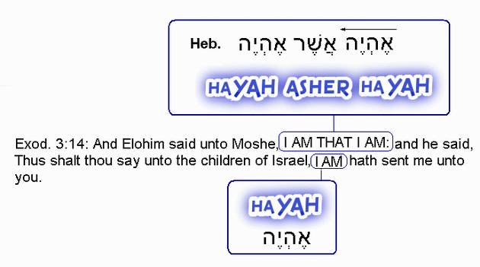

- God and science: the supernatural.
http://www.godandscience.org/apologetics/prayer.html
- The ‘oneminuteapologist’ on Youtube channel: see resurrection posts.
- Google: ‘The case for the resurrection’.
- Proofs of resurrection: https://www.youtube.com/watch?v=A0iDNLxmWVM

https://www.bing.com/videos/search?q=licona+resurrection&view=detail&mid=DF9D746471DBAC5D214ADF9D746471DBAC5D214A&FORM=VIRE

- The case for the resurrection of Jesus: Book on Amazon (Habermas & Licona)

https://www.amazon.com/gp/product/0825427886/ref=pd_sbs_14_t_1?ie=UTF8&psc=1&refRID=1KJ8D7VS1YPEW6YQJ1QJ

- The significance of the resurrection:
https://bible.org/article/significance-resurrection

- Christianity & Islam contrasted:
http://www.thereligionofpeace.com/pages/articles/jesus-muhammad.aspx

Jesus and Mohammed compared:
Not including the all-important: Resurrection of Jesus

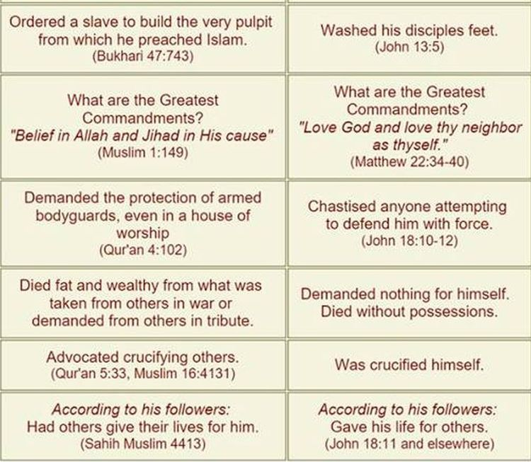
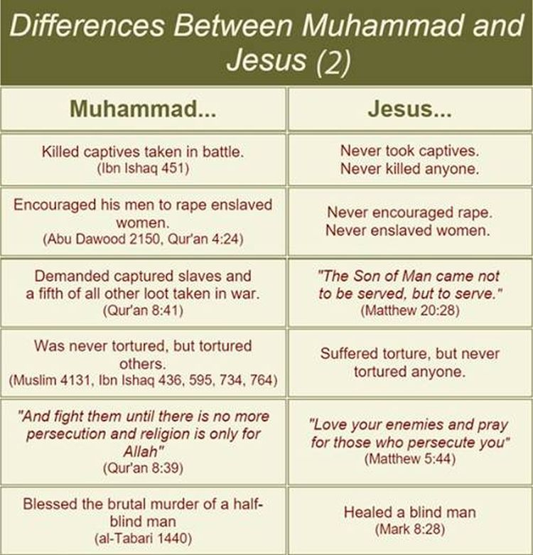

Fibonacci Sequence and the Golden Ratio

In Mathematics:

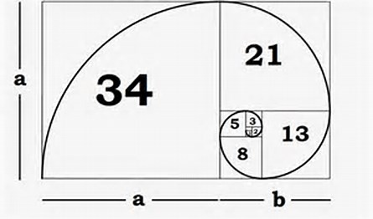

In architecture:

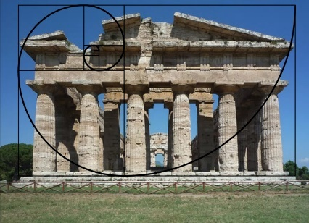

In human anatomy:

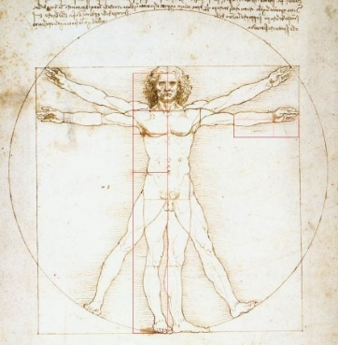

In nature:

