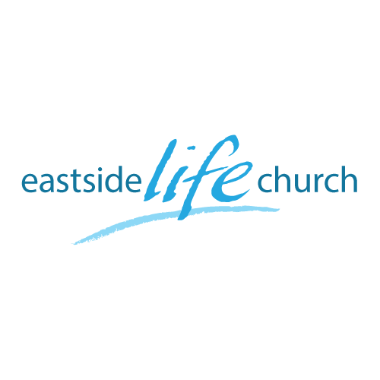
Jan 29, 2017

Forward Focus 2017: God’s Blueprint – Part 5
(If you don’t stand for something you’ll likely fall for everything)

Acts 2:42 And they continued steadfastly in the apostles’ doctrine and fellowship, in the breaking of bread, and in prayers.

Territory covered so far
- God is building His church as His habitation.
He has a plan and we have a place in it!
- God qualifies and fills us as carriers of His presence not principles.
- He equips us with an eternal message empowering us for relevant mission.
- He keeps us forward focused by cutting free from the drag of the past. “Shred it and forget it”
Key issue: unchanging propositional truth in todays’ world of relativism?
“Well it depends on your point of view.”
What is God’s viewpoint: eternal & full of grace & truth in the person of Jesus! John 1:14

It’s about the integrity of His Word: 2 Tim 3:16

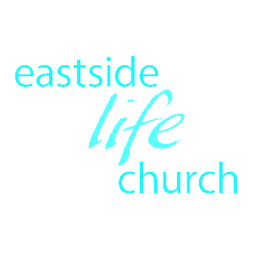
But that sounds so dogmatic!
Dogmatic: Positive - to be authoritative in what you believe.
Negative: to be opinionated & imperious
Funny that some ‘dogmatically’ believe that they don’t know what they believe.

Some historical perspective is helpful
Creeds in the Bible:
Creed: A summary of the essential contents of a doctrine of faith
OT creed: Deuteronomy 6: 4-7
NT creed: 1 Corinthians 15:3-6
Apostles Creed:

Final Take away
What has all this have to do with me and my problems?

You are confident in yourself as a messenger of your Father God.
You are confident of the ministry He has given you.
You speak His message with authority in true humility.

Notes

