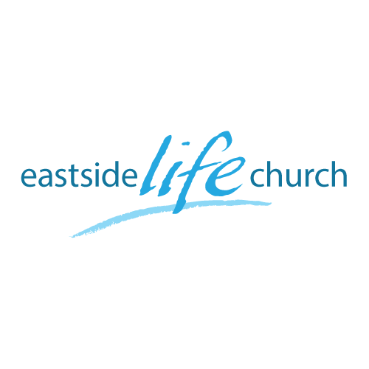
Jan 8, 2017

Forward Focus 2017 - God’s Blueprint: Part 2
God is building His Church

Distilled down
“The Old Testament prophesies of Christ, the Gospels present Christ, and the Acts and Epistles proclaim His finished work”.
Why?
How?
What?
- Jesus came to seek and save the lost… and to build His church (corporate and local) according to a pattern.
Matthew16:18
- Jesus will build it and it will work: that is settled!
POWER
OF
GOD

- It will be filled with the glory of God!
-God has already indicated He wants us in
- Do we want in on it? – that is our choice!

A ‘habitation’ for God. Eph 2:19-22
According to the pattern: 1 Cor 3:9-10
-The ‘how’ is NB: the ‘blueprint’ or plan.

Final Take Away
PURPOSE
OF
GOD

Why is the book of Acts given to us?

Goal: Prayerfully read all 28 chapters during the course of the rest of this month.

Table talk / Communion:
John 20:19-20
¹⁹ Then, the same day at evening, being the first day of the week, when the doors were shut where the disciples were assembled, for fear of the Jews, Jesus came and stood in the midst, and said to them, “Peace be with you.” ²⁰ When He had said this, He showed them His hands and His side.

- Jesus stands in the midst of our lives as an anchor of peace.
-A peace dependent on His completed work @ the cross: ‘hands & side’.

THE GLORIOUS CHURCH

PEOPLE
OF
GOD

PRESENCE
OF
GOD

PLAN
OF
GOD

