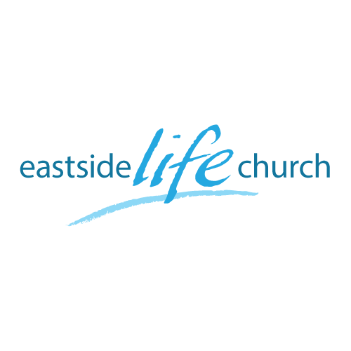
Feb 12, 2017

Forward Focus 2017: God’s Blueprint – Part 7
(The Power of Communion)

Acts 2:42 And they continued steadfastly in the apostles’ doctrine and fellowship, in the breaking of bread, and in prayers.

Review

- Key elements present in the early church.
-We should not pick & choose what suits our way of thinking.

- Rather, we are to align ourselves with His plan for building His church.
-Foundations in this ‘building’ are vital.

- The things of God in this 21st Century can be known, understood, and applied in the spirit and precision it was delivered. 1 Cor 2:12

- The HS gives us ‘revelation knowledge’ that transcends mere sense knowledge. John 14:26
- A vital relationship with the HS is not an optional extra: it’s essential.

What’s so important about “Breaking Bread”

- Whole Counsel of God’s Word conveys truth.
-OT revelation … and NT Testament

Old Testament Foundations: Types & Shadows:

- Fits into God’s unfolding plan of restoration to fullness of a liberating relationship: Spirit – Soul - Body

Passover Feast: Exodus 12: 6-9
-Innocent lamb spoke of Jesus.
-Kill at twilight: exact hour Jesus died (3 pm)
-Responsibility is to apply the blood yourself in the gateway to your household.
-Eat the flesh: personal identification & internalization.
-Roasted in fire, not boiled: speaks of fiery judgment of our sin placed on Jesus.
-A bloodless, sanitized gospel is totally ineffective.

Bronze Serpent: Numbers 21:9
-Objectionable as it may be Jesus is represented by a serpent .-Bronze is symbolic of judgment: our sin is laid on Jesus and judged.
-Our responsibility is to look at – no place for dead works.
2 Cor 3:18

New Testament: Revelation Paul received about communion
1 Cor 11:23-32

-Context: strife, division, carnality in the church: abusing grace.
-Paul brings correction.: emphasizes Jesus’ covenant in His body & His blood.
-God expects us an opportunity to ‘judge’ ourselves .
-The ‘unworthy manner’ is not to discern the Lord’s body’s role in the big picture.

This promotes bodily health (Bread = healing / Blood = forgiveness).

Final Take away

- Breaking of bread is a powerful foundational covenant proclamation of the greatness of God’s gracious provision for our well-being in Christ.

Table Talk
Communion

We release our faith by declaring God’s key provisions through communion:
- The freedom that comes from the forgiveness of our sins.
- The freedom from sickness that comes by the stripes of Jesus.

