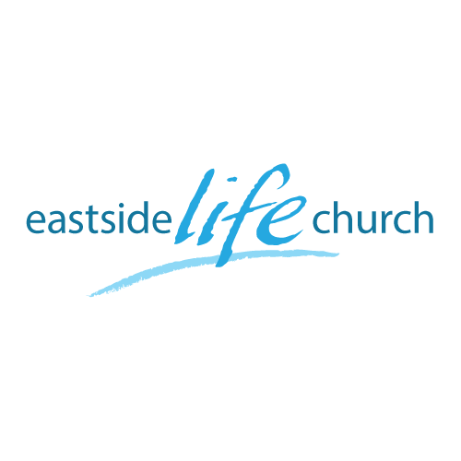
Feb 05, 2017

Forward Focus 2017: God’s Blueprint – Part 6
(The Power of Prayer)

Acts 2:42 And they continued steadfastly in the apostles’ doctrine and fellowship, in the breaking of bread, and in prayers.
Review
- Spiritual growth (maturity), fruitfulness & doctrine
You can’t grow if you don’t lay down a solid doctrinal foundation or platform.
Hebrews 6:1-2

Why is it that some people are the way they are?
(Diagram of tree: ‘Root and fruit’)

Only God can lay an ‘ax’ @ the root of an issue: individually & as a nation.
That’s why ‘behavior modification’ at the branch level, is not lasting
Paul changed from bigot to believer … through encounter !

Some more foundational stuff

Psalm 119:160 / Acts 20:27

‘7 – fold’ whole counsel of God

Prayers: The Heart of God:
To develop a meaningful and fruitful relationship with us

As Our Father, He wants us to trust Him and feels secure in our relationship. 1 John 5:14

What they prayed for in Acts?

- Prayer of response and preparation: Acts 1:14
- Established a lifestyle of prayer: Acts 2:42
- Prayer for boldness facing opposition: Acts 4:23-24, 31
- Prayer for ordination, release into authority: Acts 6:5-7
- Prayer of forgiveness: Acts 7:59-60

Final Take away

Most often, we live our lives, pray our prayers, and make hard choices in the face of opposition and challenges.

The ‘good news’ is that we have a God who overcomes in and through us:
-Lays an ax at the root of harmful patterns
-Establishes us on a sure foundation of His whole counsel
-Leads us to engage with Him in a lifestyle of fruitful prayer
and …
-Causes us to enjoy abundant life He has purchased for us.

Notes

