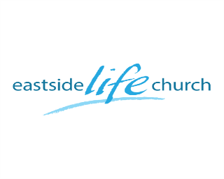

People Get Ready– Part 1
(Preparation is not lost time)

Intro:
Very often life’s moments are about 95 % preparation…
… and 10 % delivery
Ask any mother who spends 9 months preparing the child for birth and then…
The disciples prepared for the initial Holy Spirit outpouring at Pentecost
Acts 1:14
God had been setting things up for this momentous timeframe (approx. 4000 yrs!)
Galatians 4:4
God’s timing does not always equate with ours
Our job is to be prepared…
… like any sportsman will tell you in preparing for the big game.

‘People Get Ready’
Personally & Corporately (together)
Backdrop to His plan this year
God is determined to bless us
He’s given us His blueprint, starting in the Book of Acts
We are to live with ‘desire and expectancy’

What is God up to at this time?
Pouring out His Spirit in fresh waves…

Two major waves: (Early & latter rain)
Early rain for planting & growth
Later rain just before harvest

4 things God is doing in His people
He is establishing His presence as paramount in His ‘temple’
-It’s about Jesus…in us.
He is equipping us for winning as His army.
-It’s about the fight of faith.
He is positioning us in His body to function interdependently.
-It’s about relationships and giftings.
He is giving us protection and belonging in His family.
-It’s about heritage received and passed on.

What we see: (For this facility and church usage)
Develop a resource center for connecting people to God through Jesus.
- ‘Loving people to life’.
Display signage to reflect both aspects of facility use
-On street and the building (and on the internet).
Do things with a level of excellence that gives good first impressions.
-Exterior & Interior.
Facility décor to be multifunctional, thus not ‘churchy’.

More specifically:
Church focus:
Worship services
Special Series (Eg. Discovery)
Art & music encounters as outreach
Bible studies / Prayer meetings / Youth

Facility use:
Our own use
Rent out to an other church (Eg. Sunday afternoon).
Community wide Youth worship nights: “Friday night live”
Weekday seminars space rentals.

Prayer Needs:
People you’ll invite
Easter ‘launch’ service: April 16th
Favor with people in the building
Favor in the community
People drawn to this facility
Worship Leaders
Outreach engagement
‘Helps’ ministries: (Eg. Hospitality / Greeters etc)
Children’s minister’s
Youth Ministers

