Notes

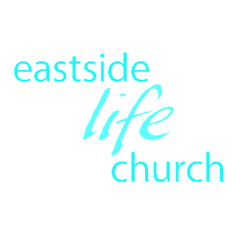

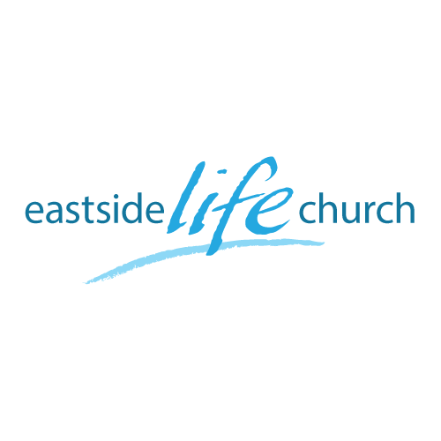
June 11, 2017

Love Life &
See Good Days
Part 4
“God’s Ways”

Welcome
Love Life & See Good Days
(Part 4: God’s Ways)

Psalm 103:7
He made known His ways to Moses,
His acts to the children of Israel

Know His ways…and cooperate with Him (1 Corinthians 2:12)

‘The divine equation’ (w=g+f)
When His sovereignty is connected to our faith, things happen.

Ephesians 2:8-10

Avoid extremes:
“If it’s to be, it’s up to me” Vs “God is sovereign”

Paul (in prison) saw things to come
Philippians 3:12 We press on by and in faith…which involves ‘receiving’ (in a continuous sense) the abundance of God’s grace.

4 key ways of God:

Jesus called His disciples into an:
Up close and personal relationship
He shaped their character to be vessels to contain His glory
He equipped them with power, authority and gifting
He released them into meaningful mission

- Relationship (Matthew 4:18)
In order to become, you have to belong first.

- In service ‘character’ training (Luke 10:17-20)
It’s a process through time…chip, chip, chip.
God uses both the bad and good things that happen in life to conform us to the image of His son. (Romans 8:28-29)

To ‘humble yourself under the mighty hand of God’ is not to begrudgingly resign yourself to ‘whatever’…but to come under His mighty hand intent to raise you up! (1 Peter 5:6-7)
The ministry of the Holy Spirit, and through the 5 fold ministry:
Apostles/ Prophets / Evangelists / Pastors / Teachers

- Empowers & equips them for service
Then He gave them authority: ‘permission’ & ‘power’ (Luke 9:1 / Luke 10:1)
- Fits us into place to function in His church (Matt 16:18- 19)
Personal involvement / promise of success / participation & power.
If you’re going to build, for heaven’s sake build on the rock
Matthew 7:24-27 – hear & do the Word and stand in times of trial
Building process:
A heap of stones or bricks is not a building:
Stones / bricks are placed in a specific place and purpose…
…after being ‘shaped’ and ‘fitted together, and based on the cornerstone.
(Picture of actual cornerstone on Temple Mount in Jerusalem)

Final Take away & Communion
He wants you to know and cooperate with His ways.
He who has begun a good work in us, will see it to completion.
Philippians 1:6
“Being confident of this, that he who began a good work in you will carry it on to completion until the day of Christ Jesus”

