Notes

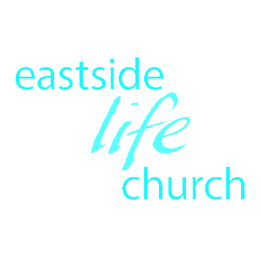

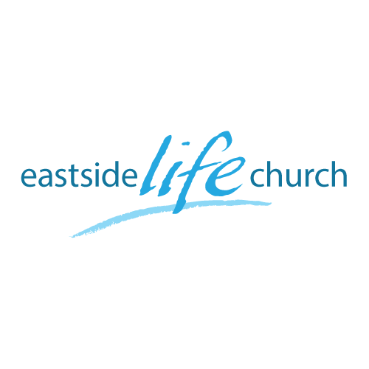
July 2, 2017

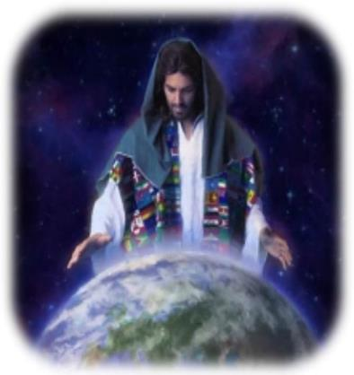

A world of Difference
Part 2
“How free is free?”

Welcome

A World of Difference
(Part 2 How free is free?)
Intro:
Is there a way to ‘filter’ out what’s untrue & doesn’t help in the long run. Answer: there is a way!
We need to develop a word based filter based on the Bible.
“The science is settled” … or is it?
- Scientists and politicians (spoiler alert) say:
-Global warming / climate change is settled
-Evolution is a proven ‘fact’ of life.
- Don’t we all feel so much better now – they’ve figured it out!?
- Good news: The Science is not settled!
- The only thing that is settled is God’s Word! Psalm 119:89

Healthy skepticism
- Because all people have an agenda, opinions, and say they have ‘science’ to back it up:
- Have a healthy ‘skepticism’ towards what we hear and see.
(Unhealthy skepticism leads to ‘cynicism’
So, what’s our agenda?
- To present to you a “world of difference” where:
-The radical good news is that in Jesus all things become brand new, and all old things have passed away.
In other words: You and I are “free indeed” John 8:34-36

Question: How free is free and what does it mean to us?

Independence Day
(241 years old this 4th July)
- The dream of independence took shape with the Pilgrims in 1620, who fled Europe to practice their religion as they saw fit.
- America was created on the basis of a ‘set of ideas’ now enshrined in the constitution: Not ethnicity, geography or nationality.
3 key ideas summarize America:
- Liberty – free to pursue our dreams
- In God We Trust – these rights & liberties are God granted
- E Pluribus Unum – from many, one. (One class of citizen: American”
Symbols: (see pictures)
- Coin - Out of many, one (Latin)
- Bell - Liberty bell: rung to announce King’s armies surrender.
- Eagle - majesty, fly above
- Flag - Red White & Blue:

God uses America even though it’s not a perfect nation:
- Slavery & the civil war are two key examples.
- Despite it’s imperfections:
-America is the world leader in supporting the Gospel worldwide through missions giving / capita.

Our citizenship carries both ‘rights’ & ‘responsibilities’
Rights of the nation: ‘constitution’
Rights of the kingdom of heaven: ‘covenant promises’
And …
Responsibilities to function as contributors to society
Responsibilities to further God’s kingdom purposes
2 Corinthians 5:20

Back to Freedom
- Jesus came to make a world of difference in us personally declaring our “independence” from:
Sin and it’s deadly consequences: now & later
Lies and deceit that rob us of God’s best
Control & manipulation of others
Sickness & distress
Luke 4:18-19

Now that we are free from sin’s negativity, we can make a world of difference in the lives of others

Final Take Away & Communion
Let us remember the depths He went to make us free indeed.
He went ‘down’ to the greatest depths
To raise us ‘up’ to the greatest heights.
Ephesians 2:4-7

