Notes

July 9, 2017

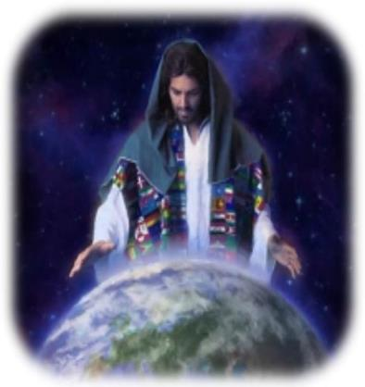

A world of Difference
Part 3
“Extreme Makeover”

Welcome

A World of Difference – Part 3
‘Extreme makeover’
Intro: Mankind needed saving from the curse of sin because of Adam’s fall.God had to send Jesus to save us & make a world of difference.

Father’s plan: Ezekiel 36:26-27

The Son’s consummation of the plan: John 19:28-30

Holy Spirit infuses us with new life: Titus 3:3-5

Paul gets an ‘extreme makeover’
Before: Galatians 1:13–14 (‘Hard hearted persecutor’)
After: Galatians 1:15-16a (Yielded heart: preacher)

Dog or Cat / Son or sinner? John 1:12 / 1 Peter 1:23

How ‘extreme’ is this makeover really? 2 Peter 1:2-4

The great jail break
- Do we step out into the wide open spaces of God’s grace, or stay put and paint the walls with murals that depict the wide open spaces outside?
- (Religiosity is characterized by ‘distance’ & ‘delay’)
- If I step out won’t I be tempted to abuse that freedom?
- I think I’ll play safe and just exercise in the prison yard.
Holy Spirit to the rescue: Romans 8:14
- The Holy Spirit within us always leads in a righteous direction helping us to function within God’s grace realm.

But what if I do fall in sin as a Christian?
- We fall within the ‘ark’ of God’s realm of grace!
-Not in and out of His safety.
- To fall from grace is not to give in to some temptation:
Eg. some passion of the flesh like
But…
- To fall from grace is to go back to relying on your own efforts under the ‘law system’, and thus negate Jesus work on our behalf on the cross.
“The just shall live by faith”

Galatians 5:1-4

‘Once upon a time’ – chicken and eagle story

- Choose to ‘fly high’ into the wide-open spaces of grace
- As you believe right you’ll behave right.

Final Take Away & Communion
God took extreme measures to give us an extreme makeover
- If salvation is simply about being good to people, and following Jesus’ example, it mocks the extreme suffering Jesus endured to rid us of sin.
2 Corinthians 5:21
For He made Him who knew no sin to be sin for us, that we might become the righteousness of God in Him.

From ‘sinner’ (by nature) to ‘saint’ (by birth)

