Notes

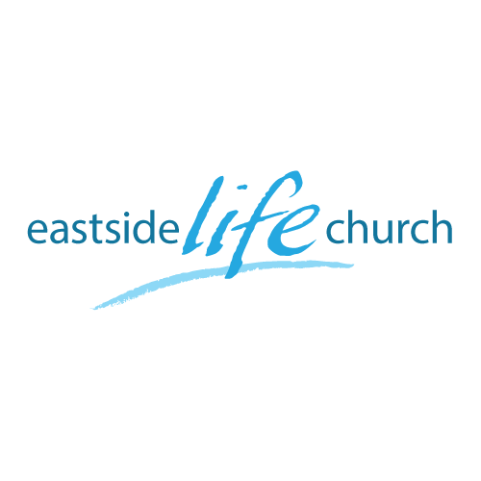
July 16, 2017

A world of Difference
Part 4
“Wanted: Dead Or Alive”

Welcome

A World of Difference – Part 4
‘Wanted: Dead or Alive’

Words matter:

‘Life’ – physical and spiritual connection to the source
‘Death’ – physical and spiritual separation from the source of life
‘Sin’ – actual deeds that fall short of God’s moral perfection
‘Sin nature’ – that propensity in all men to commit sins
‘Freedom & liberty’ – a state of being where you get to do God’s will without fear.

It’s already done: Romans 6:1-4

Trying to die does not work!
You are trying to do something that has already been done!
By Jesus on our behalf & we enjoy the benefit when we know it, and apply it in faith.

Tenses matter: Ephesians 2:1-10

Did Jesus die because He committed sins, or was it that our sins were imputed to Him? 2 Corinthians 5:21

Insecurity weakens you: Romans 6:8

We are freed from ‘sin’ (noun) - the condition and propensity to sin, (not necessarily from sinful actions & deeds).

Yet we still sin (on occasion), but not as a lifestyle, and if we do, we are still ‘secure’!

Question corner:

Question: How close are we really with Him?
Answer: Very close. (We are in Him and He in us!)
2 Corinthians 5:17

Life side of equation: Romans 6:5-11

Made free from the law of sin and death: Romans 8:1-2

Application:

- Reign (as a king) in life through Jesus - Romans 5:17
- Set your heart and mind on things above - Colos 3:1-3
- Stand your ground - Galatians 5:1

Final Take Away & Communion

God is not focused on our sins, but on His Son

