Notes

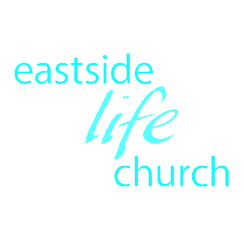

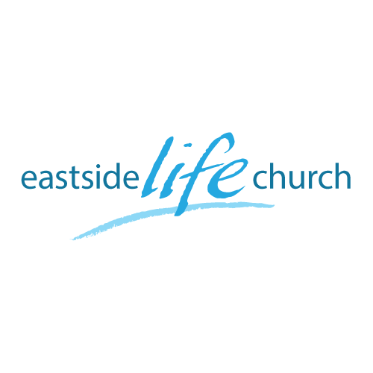
July 23, 2017

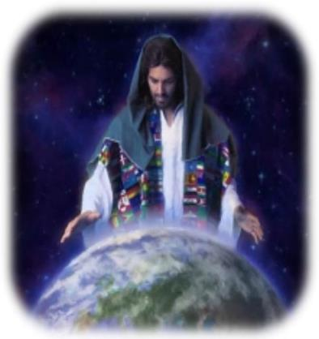

A world of Difference
Part 4
“How then should we live”

Welcome

A World of Difference – Part 5
‘How then should we live’

Question:
Did Jesus come to introduce us to a new improved version of the rules and principles (a V2.0)?
or …
Answer:
To introduce us to a new way of living where our lives are not based on a set of principles (like all other religions) but on His person: His saving grace through His completed work on the cross.

But wait:
The golden rule, Honesty, Respect, Discipline etc ..
These are all noble values in all societies, but even if you ‘try hard’ to obey the rules or principles, you are sure to slip up somewhere, sometime!

The new way of life is not about a constant focus on right and wrong?
Should I watch this movie?
Should I listen to this or that music
Should I put make up on?
Should I pray one hour or two every day?
Should I drink beer or wine or not at all?

These are all the wrong questions.

The right question is this:
“Am I abiding restfully in Christ (faith) ,and …
… hearing His voice on the matter (leading of the Holy Spirit).

Romans 1:17 Romans 8:14

There were two trees in the garden
- Tree of life
- Tree of the knowledge of good and evil
Which one should Adam & Eve have focused on, and which one do we today need to focus on?
One speaks of relationship, willful obedience and delight
the other of rules, fearful obedience and duty.

Consequences of being value & principle driven

- You will be self-conscious (demand & lack) rather than God conscious (supply and abundance) Romans 5:17

- It will keep you in bondage to a frustrating ‘performance based’
approach to God.
-An impossible hill to climb: where good is not good enough.

That’s one of key purposes of the Law: to show us the impossibility of keeping it, and therefore our need of a savior.
-The Law shows us where we don’t ‘look right’, but is ‘powerless to change’ the way we look.

Only Jesus has the power through His shed blood to change our nature.

Final Take Away & Communion

Hebrews 10:19-24
¹⁹ Therefore, brethren, having boldness to enter the Holiest by the blood of Jesus, ²⁰ by a new and living way which He consecrated for us, through the veil, that is, His flesh,
²¹ and having a High Priest over the house of God, ²² let us draw near with a true heart in full assurance of faith, having our hearts sprinkled from an evil conscience and our bodies washed with pure water.

