NewsBoys

‘Wherever we go’

Wherever we go, bluebirds sing
And the flowers bloom and the grass gets green
It's a curious thing
But it's just our thing

Wherever we go, the bees behave
In the treetops, squirrels smile and wave
It's a curious thing
And it's humbling

Where we go, little glow-worms glow
Little roadrunners run ahead
Gonna tell their friends
Little mice, little men
Get 'em all excited, all invited

Hands up, holler back here
Let's throw this party in gear
We brought the welcome mat
Wherever we go, that's where the party's at
Hands up, holler back now
We don't claim any know-how
We're giving God all that
Wherever we go, that's where the party?s at

Wherever we go, the dumb get wise
And the crime rates drop and the markets rise
It's a curious thing
But it's just our thing

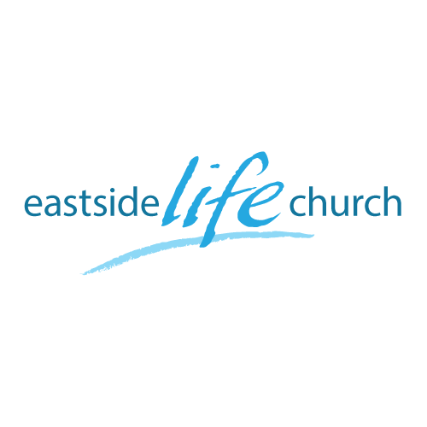
Dec 3rd, 2017

Answering Life’s Big Questions

Part 4
“What is God’s will for me - B”
(Some specifics this time)

Welcome

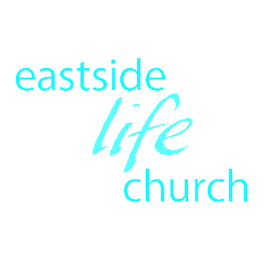
Answering Life’s Big Questions – Part 4
“What is God’s will for me - B‘’
Some specifics

Fulfilling God’s will is based on a sure foundation of His work in and through us: Ephesians 2:8-10

So, your life is ‘kinda’ mapped out for you: it’s not ‘totally random’

All this largely in community with like-minded believers
(Role of the ‘local’ church) Ephesians 2:19

The power of a dream: Acts 2:16

We are about: ‘Facilitating your dreams’

This happens primarily through equipping you in the Word
And
Ministering the life transforming power of the Holy Spirit

How can I know God’s will on a micro scale

Guidance / leading of the Holy Spirit:

Key Principle: as long as your decisions don’t take you away from fulfilling the ‘macro’ aspects of your destiny: encounter / enjoy / express.

“In and Out” Opportunities

Church … and community related

As the church, wherever we go we influence the atmosphere!

The apostle Paul is led by the Holy Spirit

Acts 16:6-10 – ‘forbidden’ and ‘not allowed’ by the Holy Spirit !?

God encourages personal involvement in decision making
Acts 15:28 /1 Thess 3:1/ Titus 3:12

How to be sure what God’s will is

1. In line with God’s Word: John 17:17
If it’s in the Word it’s His will (Playing field)

2. Characterized by peace: Isaiah 55:12
(Your default position)

3. It will have a ‘touch of heaven’ in it: Matthew 6:10
Something that pleasantly surprises you
(special – not ordinary).

4. In line with your uniqueness: 1 Peter 4:10-11
Your spiritual gifting
What moves you (reoccurring dream) and/or bothers you
Personality & Experiences

5. In concert with / connected to the local church & rest of the body.
Part of the team: ‘knitted in’ & not an isolated brick.
In a place reserved just for you.
1 Corinthians 12:12

6. Your sphere of influence in the community: Mark 16:15
Eg. Extended family / Schools / Community groups

Final Take Away & Communion

If it’s the Word
And
The Holy Spirit given guidance & peace is there
And
It aligns with leadership.

Then I can step out in faith
confident that it is God’s will for me.

