Dec 25th, 2017
Notes

The wise men and His star – Matthew 2:1-2

The 12 constellations tell His story.

The Christmas story is unique – one of a kind.

It’s worth checking out what it means for us today.

Jesus ‘saw’ things differently – Isaiah 11:3-4

How does this apply to me today? – John 8:12

www.eastsidelifechurch.org

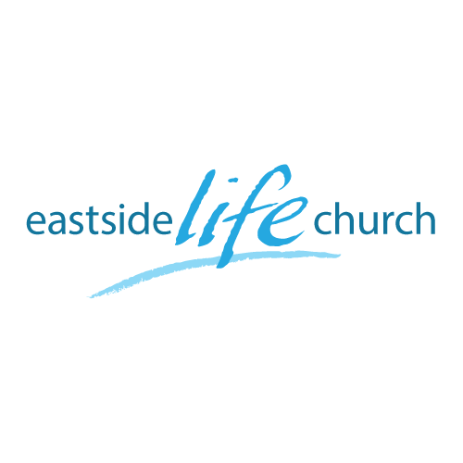

Christmas 2017

Welcome

Oh, Holy Night

O holy night
The stars are brightly shining
It is the night of our dear Saviour's birth
Long lay the world in sin and error pining
Till He appeared and the soul felt its worth
A thrill of hope the weary world rejoices
For yonder breaks a new and glorious morn
Fall on your knees
Oh, hear the angel voices
O night divine
Oh, the night when Christ was born
O night divine
Oh, night
Oh night divine

The Light of the World

The world waits for a miracle
The heart longs for a little bit of hope
Oh come, oh come, Emmanuel
A child prays for peace on Earth
And she's calling out from a sea of hurt
Oh come, oh come, Emmanuel

And can you hear the angels singing
Glory to the light of the world
Glory, the light of the world is here

The drought breaks with the tears of a mother
A baby's cry is the sound of love
Come down, come down, Emmanuel
He is the song for the suffering
He is Messiah, the Prince of Peace has come
He has come, Emmanuel

Glory to the light of the world
Glory to the light of the world
Glory to the light of the world
Glory to the light of the world
For all who wait
For all who hunger
For all who've prayed
For all…

