Notes

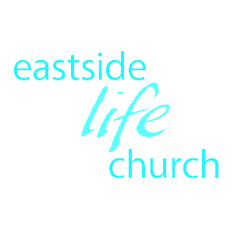

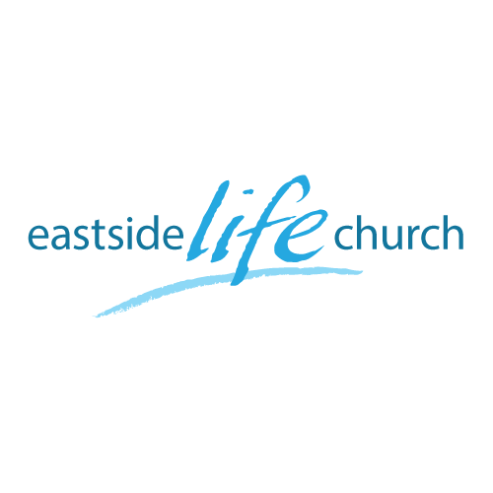

Jan 7th., 2017

More in Store

Part 2
“Standing on Solid Ground”

Welcome

More in Store – Part 2
“Standing on Solid Ground”

Turning over a new ‘leaf’ or a whole book.
Resolve: ‘decide firmly on a course of action’.
Revolution: ‘overthrow of an order in favor of a new system’.
Revelation: ‘God’s Word and Spirit disclosing to you what you need’.

Value & limitations of New Year resolutions:

Value:
Points you in a definite direction: goals & timetable.
The ‘reset’ button gives you a sense of a fresh start free
from guilt & disappointment.

Limitations
Give a target sure, but not the energy / power to get there.
Can lead to disappointment if & when we fall short.

Solutions?

Two-sided coin:
1. God’s side of the relationship:
Potter & the clay: We cannot make ourselves more
like Jesus, any more than a lump
of clay can make itself into a vase.
Matthew 6:27
Worry negates our faith
He is the initiator, we are the responders,….so…
The Word, prayer & conversation discern what God wants to change.

2. Our faith response: The other side of the coin.
Romans 5:2
Grace supplies what we need - God’s side is to initiate.
Faith accesses what is supplied - our side is to respond.

The stream and the tree: Jeremiah 17: 7-8

Back up a bit to ‘joy”

Joy is fruit of the spirit.
It looks forward and is dependent on God’s promises, not the circumstances.
It involves: “a confident expectation of good that impacts your sense (or feeling) of well being”.

The operation of your faith is critical to walking in victory:

I John 5:4

Faith accesses God’s provision
Faith pleases God
The ‘spirit’ or essence of faith is to believe and speak it out
But

What happens when you are challenged to back off what you are trusting God for?

We are told to stand our ground!
Withstanding your adversary is an act of faith.

Ephesians 6:13-14

Which is it to be this year?
“Grab the bull by the horns?” Or “Let go and let God”
“Don’t just stand there… Or “Don’t do something, just stand”
…do something.
Resting in faith is predicated upon:
Knowing God’s will & His ways.
Releasing your faith by believing the promises & declaring them.

Final Take Away & Communion

We live effortlessly from a place of victory…
Christ’s victory achieved by Him for us.
And not from a place of defeat…desperately trying to make it!

1 Corinthians 15:57
But thanks be to God, who gives us the victory
through our Lord Jesus Christ.

