Notes

March 18th 2018

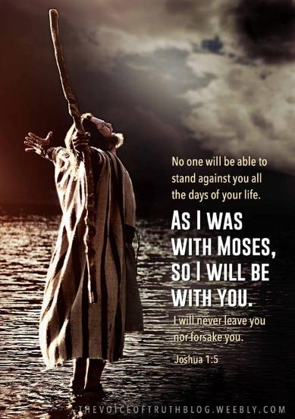

Possess the Land - 2
“What Happened”

Welcome

Possess the Land – Part 2
What Happened?

God’s people miraculously taken out of Egyptian slavery…
(‘Minus’ of sin)
…to be taken into their “Promised Land”
(‘Plus’ of righteous living)

God’s promises: 2 Corinthians 1:20

“Spy Story” (@ Kadesh Barnea)

Numbers 13:1-2 – the instruction to spy out the land.
Numbers 13:27-28 – the conflicting reports.

The mirror of God’s Word: James 1:22-24

The majority is always right…right? (not always)

Things quickly unravel and the nation
goes South…literally! Numbers 14:1-4

Take matters into their own hands … and fail.

God repeats His promise. Numbers 15:2

Application: So what?

All God’s promises received by grace through faith.

Romans 5:17
What part do we play?

1. Find the promise that applies to the situation.
-Be convinced by allowing the Lord to write it on your heart.
2. Begin to declare / say over your life situation.
-Lay your foot on the ground you will stand on.
3. ‘Stand your ground’ when things look otherwise.
-Keep your eyes on the promise.

Final Take Away & Communion

2 Corinthians 4:13
¹³ And since we have the same spirit of faith, according to what is written, “I believed and therefore I spoke,” we also believe and therefore speak,

God has promised His provision for our:
Forgiveness and
Healing and
Well being
We appropriate / receive all these by faith (a gift He gives us).

