Notes

Jesus has delivered us from the fear of death:

Hebrews 2:14-15
¹⁴ Inasmuch then as the children have partaken of flesh and blood, He Himself likewise shared in the same, that through death He might destroy him who had the power of death, that is, the devil, ¹⁵ and release those who through fear of death were all their lifetime subject to bondage.

April 8th 2018

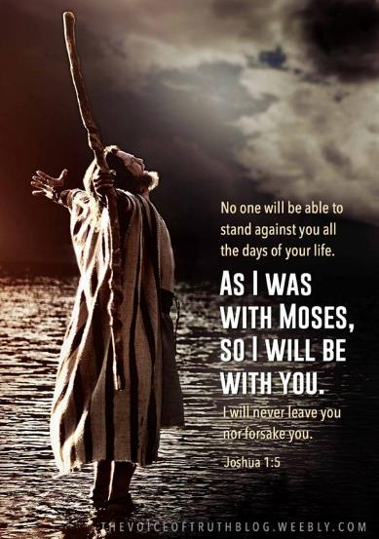

Possess the Land - 4
“Overcoming the giants in life”

Welcome

Possess the Land – Part 4

Since the fall: - Genesis 3:9-10

Experts tell us that babies have two natural fears:
The fear of falling and the fear of loud noises.
A study on fear conducted on 500 adults showed:
They shared some 7,000 different fears.
Therefore they learnt 6,998 fears since they were born.

Since Jesus rose from the dead:
“Faith” is our default posture

Hebrews 2:14 / 2 Corinthians 4:13

Reassured as they were about to go in to possess the land:

Deuteronomy 20:1-4

What you ‘see’ with your natural eye can cause fear.
Which is bigger?
God’s Promises or Circumstance’s Pressure.
It’s our choice not to fear.

Do not allow your true identity as God’s covenant treasure to become secondary.
Allow God to rollaway any reproach.

Why did God’s people still have to fight the giants in the land?
- The giants want to keep what they have – so, we have to enforce their defeat.
- As good soldiers of the Lord we develop hardiness for greater conquests to follow.

1 Timothy 6:12 / Hebrews 12:2

Completed work of Jesus Vs Fearful circumstances

Satan’s dirty little secret! – He’s fearful of us.

Joshua 5:1 / Luke 10:19 / James 4:7

Final Take Away & Communion

2 Timothy 1:7
For God has not given us a spirit of fear, but of power and of love and of a sound mind.

X-tra Note:

Deuteronomy 7:1-2
“When the Lord your God brings you into the land which you go to possess, and has cast out many nations before you, the Hittites and the Girgashites and the Amorites and the Canaanites and the Perizzites and the Hivites and the Jebusites, seven nations greater and mightier than you, ² and when the Lord your God delivers them over to you, you shall conquer them and utterly destroy them. You shall make no covenant with them nor show mercy to them.

