Notes

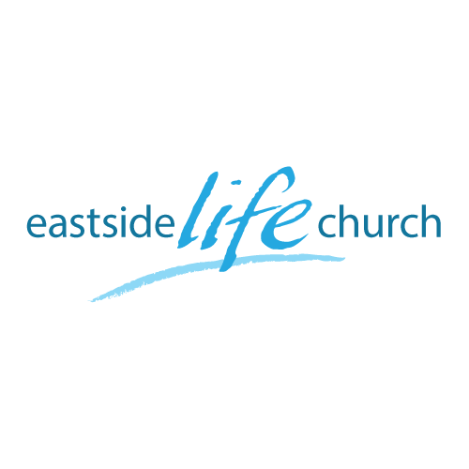
June 17th 2018

Staying on Track - 8
“The Good Shepherd sings over us”

Welcome

The first Sunday of the Rest (Best) of your life

2018

Staying on Track – Part 8

Foundational Scripture

1 Thessalonians 5:23-24
Now may the God of peace Himself sanctify you completely; and may your whole spirit, soul, and body be preserved blameless at the coming of our Lord Jesus Christ.
²⁴ He who calls you is faithful, who also will do it.

The Good Shepherd sings over us

John 10:11,27
¹¹ “I am the good shepherd…
²⁷ My sheep hear My voice, and I know them, and they follow Me.

Shepherds were usually the youngest in the family – Eg. David.
Shepherds had a rod & staff, a sling, scrip and a flute.
Shepherds were always close to their sheep: “called each by name”
(Speaking & singing to them, guiding and protecting them).

The shepherd always brought about provision, peace and purpose. Psalm 23

God wants you to be secure, and sure of things:
The Good shepherd (Jesus) invites us to follow Him and then He ‘makes’ us into close followers – “disciples”.

The ‘sound’ of music & song:

Zephaniah 3:17
¹⁷ The Lord your God is in the midst of you, a Mighty One, a Savior [Who saves]!
He will rejoice over you with joy; He will rest [in silent satisfaction] and in His love He will be silent and make no mention [of past sins, or even recall them];
He will exult (rejoice) over you with singing.

Eg. David the Psalmist was a worshipping shepherd who sung to his sheep.
He was also a warrior who would protect sheep with His life!
Jesus is described as the “Son of David” - a term for the Messiah.
He is both the lover of our souls, and our strong protector.

At the Last Supper – the Good Shepherd, Jesus, continued to perfectly reveal the Father when he led the disciples in…
…singing a hymn (Psalm 118 )
What a singer He was, and still is.

Matthew 26:26-28,30
As they were eating, Jesus took some bread and blessed it. Then he broke it in pieces and gave it to the disciples, saying, “Take this and eat it, for this is my body.”
27 And he took a cup of wine and gave thanks to God for it. He gave it to them and said, “Each of you drink from it, 28 for this is my blood, which confirms the covenant between God and his people. It is poured out as a sacrifice to forgive the sins of many…
30 Then they sang a hymn and went out to the Mount of Olives.

Final Take Away & Communion
As we celebrate Communion,

Isaiah 53:6
All of us like sheep have gone astray, Each of us has turned to his own way; But the LORD has caused the iniquity of us all To fall on Him.
Our iniquity fell on Him,
and His righteousness fell on us!

Isaiah 53:7
He was oppressed and He was afflicted,
Yet He opened not His mouth;
He was led as a lamb to the slaughter,
And as a sheep before its shearers is silent,
So He opened not His mouth.

He remained silent…
…so that we could proclaim His goodness to all.

