Notes

The Fourth of July was coming up, and the nursery school teacher took the opportunity to tell her class about patriotism.
"We live in a great country," she said.
"One of the things we should be happy is that, in this country, we are all free."
One little boy came walking up to her from the back of the room.
He stood with his hands on his hips and said, . . .
"I'm not free. I'm four."

What's red, white, black and blue? Uncle Sam falling down the stairs.

What kind of tea did the American colonists want? Liberty.

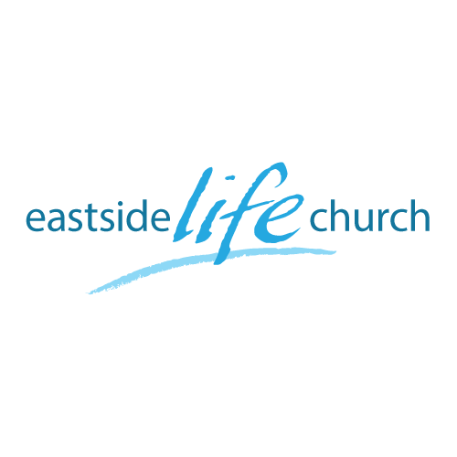
July 1st. 2018

“Freedom’s Cry”

Welcome

The first Sunday of the Rest (Best) of your life

2018

National Anthems

Anthem: a song or hymn of praise or gladness, a patriotic song.
USA
4th. Verse of Star Spangled Banner
(Composed in 1814 & adopted nationally in 1931)

O thus be it ever, when freemen shall stand
Between their loved homes and the war's desolation.
Blest with vict'ry and peace, may the Heav'n rescued land
Praise the Power that hath made and preserved us a nation!
Then conquer we must, when our cause it is just,
And this be our motto: 'In God is our trust.'
And the star-spangled banner in triumph shall wave
O'er the land of the free and the home of the brave!

South African National Anthem
“Nkosi sikelel' iAfrika”
(Composed in 1897 by a Methodist School teacher as a hymn)

Lord, bless Africa,
May her spirit rise high up.
Hear thou our prayers,
Lord bless us.
Lord, bless Africa,
Banish wars and strife.
Lord, bless our nation,
Of South Africa.
Ringing out from our blue heavens,
From our deep seas breaking round,
Over everlasting mountains,
Where the echoing crags resound.
Sounds the call to come together,
And united we shall stand,
Let us live and strive for freedom,
In South Africa our land.

Pointers Today

The Israelites groan & cry out for “freedom”
Exodus 2:23-25

Other cry’s heard around the world: Africa: “Uhuru”
East Germans / Child Sex Slaves

The “land of the free and home of the brave”
(The Constitution) - Judeo Christian Roots
Acknowledgement & Appeal to the creator.
Freedom came at a price to the signers.

God’s Plan for Nations: Acts 17:26-27

Jesus said this about the church’s role in any nation:
Matthew 28:19

How does the church disciple a nation?
By engaging with society in every area.

Proverbs 14:34 Righteousness exalts a nation: but sin is a reproach to any people.

‘Religious Freedom’ In America – what to do now?

Our Declaration of Freedom: Luke 4:18-19
God making us His children: Galatians 3:26
God sends His Spirit into our hearts: Galatians 4:6
Acts 4:12 / John 8:36

“We the people of God, because of God’s gracious love for us by sending Jesus who bled, died and rose again for our freedom: …

****

