Notes

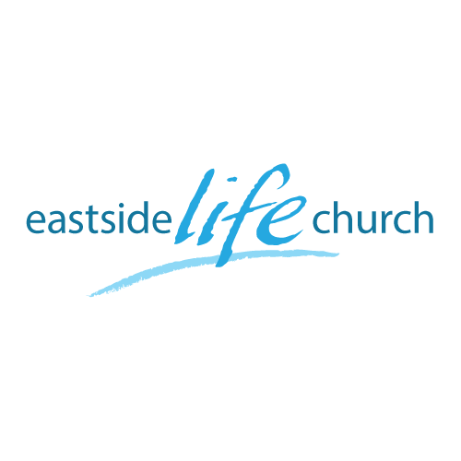
July 8th 2018

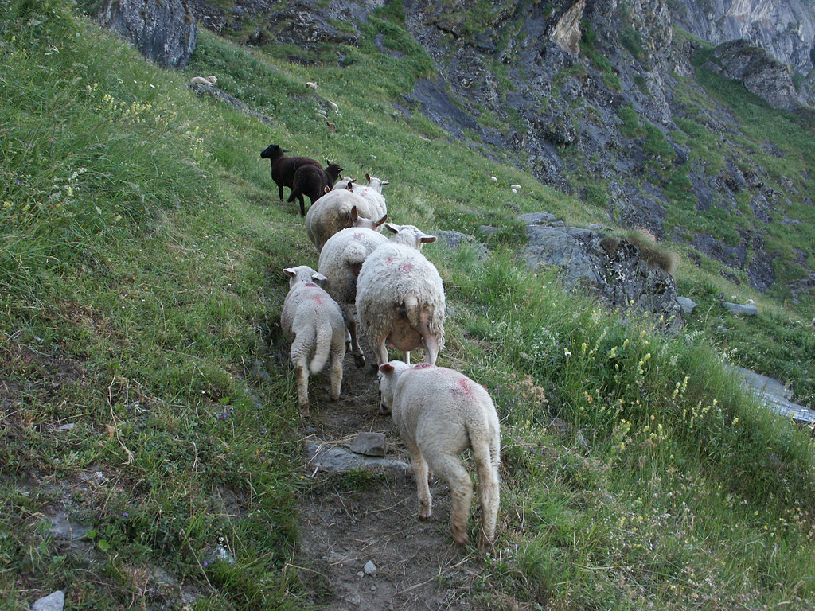

Walking in Freedom - 1
“Faith – the way we receive from God”

Welcome

The first Sunday of the Rest (Best) of your life

2018

Walking in Freedom – Part 1
The way we receive from God

Foundational Scripture

Jeremiah 6:16
This is what the LORD says: "Stand at the crossroads and look; ask for the ancient paths, ask where the good way is, and walk in it, and you will find rest for your souls.

Jesus our Good Shepherd leads us along these tried & tested paths.

The Pathway of Faith

2 Corinthians 5:7
For we walk by faith, not by sight.

Abraham’s example: Hebrews 11:8

- Faith is a journey with many steps.
- Some steps are wrong, but the Good Shepherd brings us back.

God is pleased with our faith & rewards it
Heb 11:6

2 kinds of faith:
- The 'Thomas kind of faith' needs to see the end result first, before believing. This is not real Bible faith.
John 20:25

- The 'God kind of faith' believes the promises of the Word first, before seeing the result come to pass. This is true faith.

Faith has a voice ‘Believe & speak’

2 Corinthians 4:13 / Mark 11:23-24

Where faith comes from?
Faith is available to whosoever responds to God’s promised provision.

Romans 10:17
¹⁷ So then faith comes by hearing, and hearing by the word of God.

Faith begins where the will of God is known

Final Take Away & Communion
As we celebrate Communion,

Ephesians 2:8-10
⁸ For by grace you have been saved through faith, and that not of yourselves; it is the gift of God,
⁹ not of works, lest anyone should boast.
¹⁰ For we are His workmanship, created in Christ Jesus for good works, which God prepared beforehand that we should walk in them.

Notice how grace, faith, works and destiny connect.

