Prayer Focus This Week

Ephesians 3:14-19
¹⁴ For this reason I bow my knees to the Father of our Lord Jesus Christ, ¹⁵ from whom the whole family in heaven and earth is named, ¹⁶ that He would grant you, according to the riches of His glory, to be strengthened with might through His Spirit in the inner man, ¹⁷ that Christ may dwell in your hearts through faith; that you, being rooted and grounded in love, ¹⁸ may be able to comprehend with all the saints what is the width and length and depth and height— ¹⁹ to know the love of Christ which passes knowledge; that you may be filled with all the fullness of God.

- Pray that you (and those you pray for) be strengthened with might to face the challenges that come.

- Pray that Christ may ‘dwell’ (settle down and take up residence) in your heart regarding unsure things.

- Pray that you are ‘rooted and grounded’ in His love for you.

- Pray that your eyes are open to enjoy all the dimensions of His love towards you and through you.

The promise:
When we receive the love of God for us, we are ‘full of God’: for God is love. (Vs 19),

Exercise:
Meditate on what the 4 dimensions of God’s love are.

August 5th 2018

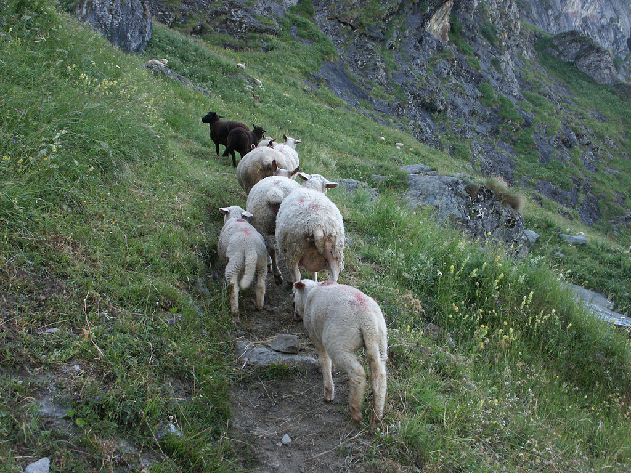

Walking in Freedom - 3
“A Love that never fails”

Welcome
The first Sunday of the Rest (Best) of your life

2018

Walking in Freedom – Part 3
A love that never fails

Foundational Scripture

Jeremiah 6:16
This is what the LORD says: "Stand at the crossroads and look; ask for the ancient paths, ask where the good way is, and walk in it, and you will find rest for your souls.

Jesus our Good Shepherd leads us along these tried & tested paths.

The Pathway of Love

The ‘God kind’ of Faith, Hope & Love
Have worked in the past, work now and will always work in the future

1 Corinthians 13:13
Three things will last forever--faith, hope, and love
and the greatest of these is love…

(it never fails to deliver)

‘Love’ goes out of His way to heal ‘Mad Max’ from Gadara.
Mark 5:1-20
Then they came to the other side of the sea, to the country of the Gadarenes. ² And when He had come out of the boat, immediately there met Him out of the tombs a man with an unclean spirit, ³ who had his dwelling among the tombs;

The apostle John understood that Love allows you to get close.
John 13:23
One of his disciples, whom Jesus loved, was reclining at table at Jesus’ side,

Love allows the Lord to serve you
Are you a Peter or John?

John 13:1-16
Peter resisted, John received.

Final Take Away & Communion
As we celebrate Communion,

The apostle John wrote about love years later after the cross:
1 John 4:10
In this is love, not that we loved God, but that He loved us and sent His Son to be the propitiation for our sins.

His love for us is our sure foundation
for walking in freedom

