Prayer Focus This Week

Take this scripture and pray over yourself and your involvement in what God is doing and wants to do in and through His church:

Matthew 16:13-19
¹⁵ He said to them, “But who do you say that I am?”
¹⁶ Simon Peter answered and said, “You are the Christ, the Son of the living God.”
¹⁷ Jesus answered and said to him, “Blessed are you, Simon Bar-Jonah, for flesh and blood has not revealed this to you, but My Father who is in heaven. ¹⁸ And I also say to you that you are Peter, and on this rock I will build My church, and the gates of Hades shall not prevail against it. ¹⁹ And I will give you the keys of the kingdom of heaven, and whatever you bind on earth will be bound in heaven, and whatever you loose on earth will be loosed in heaven.”

“Heavenly Father,

Thank you for calling me into the family of your church which You Lord Jesus are building. I have a part to play, so I ask you to fill me with wisdom and opportunity to extend your Kingdom through the church.

I loose your favor over me and my family, my church, community and nation.

In Jesus name I pray”.

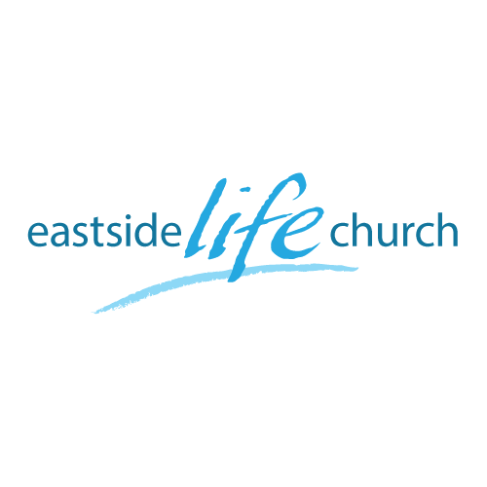
September 9th 2018

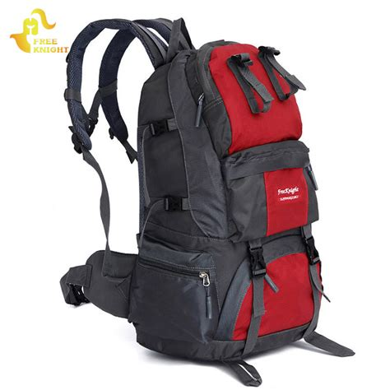

Back to Church - 1
“A starting Point”

Welcome
The first Sunday of the Rest (Best) of your life

2018

Back to – Part 1
“A starting point”

Foundational Scriptures:

Matthew 16:18a
…on this rock I will build My church, and the gates of Hades shall not]prevail against it

Why any church (should) exist

Encounter… God’s abundant grace found in Christ
Enjoy…a life full of meaningful purpose
Express…His love in the world through word and deed.

Love, forgiveness & acceptance
in Christ

The Church is Jesus idea

(Matthew 16:13-19)

You are the Christ’
Revelation of His divine person
‘I will build my church’
Jesus’ purpose is to build a winning community
‘Keys of the kingdom’
Our participation is to unlock destiny in people

Small or large?

Matthew 18:20 / Romans 16:5 / Revelation 2:1

The benefits of engaging with a church community
(Acts 2:40-42)
Doctrine’
Wholesome teaching that equips to lead a fulfilling life
‘Fellowship’
Involvement in something bigger than yourself
‘Breaking of Bread’
Opportunities to keep Jesus central & foundational
‘Prayers’
Connecting with God and all that we have need in Him
Life is a journey that requires equipment:

‘Clothing’ - Identity and protection
‘Equipment’ -Cooker, pots & plates
‘Maps’- Pathways

Eastside Life Church
Vision

- We see you fulfilling your God planned destiny with lasting purpose and fulfillment in community with like-minded people.
- To this end, we see a multi-generational church focused on Jesus’ magnificent love, compassion and power to make a difference to a world full of need.

We are about facilitating
your God given dreams
and …
‘Loving people to life’

Pathways: Connect – Grow – Serve - Lead

