Prayer for this week:

Dear Lord,

Fill me with a fresh appreciation of your power to overcome every obstacle I face.

Give me the wisdom and understanding I need to know the hope of my calling as a believer.

Help me cooperate with You in faith to make room for the way maker in my circumstances.

I trust in You and lean not to my own limited understanding to do that which you have promised to do.

I praise and thank You for bringing me this far, and I expect miraculous breakthroughs in my health, well-being and areas of need.

In the name above all names I pray: Jesus!

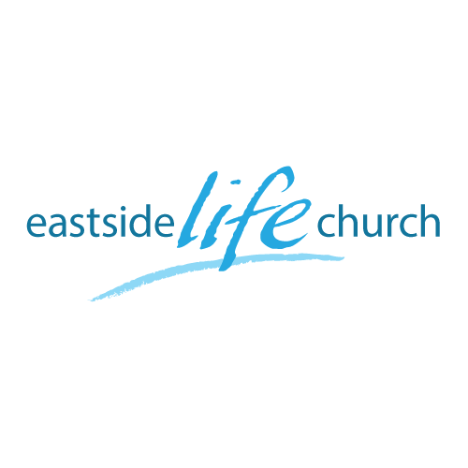
September 23rd 2018

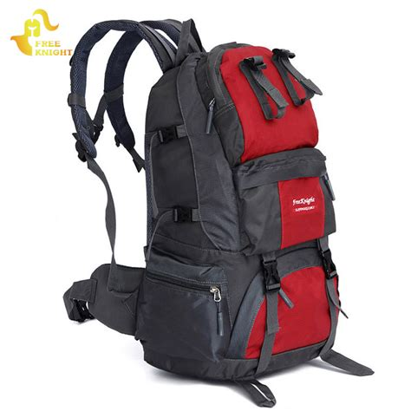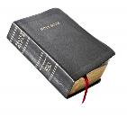

Back to Church - 3
“The Miraculous Work of the Holy Spirit”

Welcome
The first Sunday of the Rest (Best) of your life

2018

Back to Church– Part 3
“The Miraculous Work of the Holy Spirit”

Foundational Scripture: 1 Corinthians 4:20
For the kingdom of God is not in word, but in power.

When it seems that the Word is not enough…

How Jesus performed miracles
Acts 10:38

What about us?

Peter’s example: Acts 10:44 / 1 Cor 3:9

But Peter was an apostle! The example of Philip a deacon.
Acts 6:3-5 / Acts 8:4-8

The miraculous does not just fall in our laps

Jude 3 – ‘contend’ – strive against with effort
Religious and cultural / social opposition.

Why do we need miracles?

Modern medicine falls short very often.
We need God’s higher power of redemption.

Application

Desire the miraculous
Recognize the Holy Spirit’s work
Expect the miraculous.

Final take Away & Communion

When it looks like there is no way out, Jesus makes a way.
“the way, the life and the truth” (John 14:6)
Way Maker - Sinach

You are here, moving in our mist
I worship you
I worship you
You are here, working in this place
I worship you
I worship you (2X)
Way maker, Miracle worker, promise keeper
Light in the darkness, my God...
That is who you are (2X)
You are here, touching every heart
I worship you
I worship you
You are here, healing every heart
I worship you
I worship you
You are here, turning lives around
I worship you
I worship you
You are here, mending every heart
I worship you
I worship you
Way maker, Miracle worker, promise keeper
Light in the darkness,
That is who you are
Way maker, Miracle worker, promise keeper
Light in the darkness, my God...
That is who you are
You wipe away all tears, you mend the broken heart
You are the answer to it all, Jesus...
You wipe away all tears, you mend the broken heart
You are the answer to it all, to it all Jesus...
Way maker, Miracle worker, promise keeper Light in the darkness

