Notes

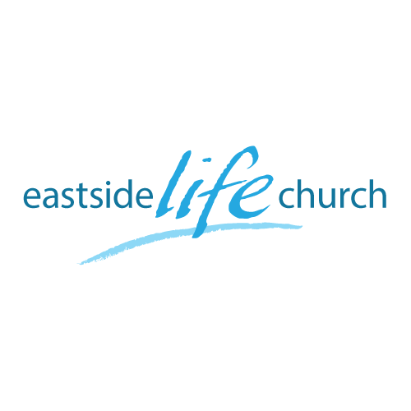
October 28th. 2018

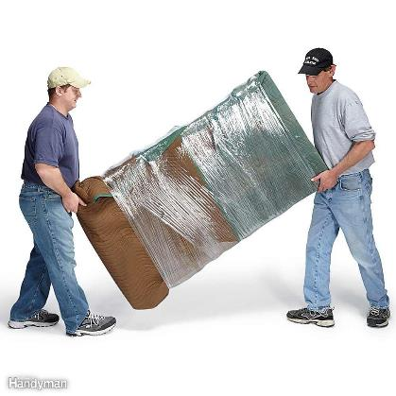

All the Help You Need - 1
“ The Helper”

Welcome
The first Sunday of the Rest (Best) of your life

2018

All the Help You Need– Part 1
“The Helper”

John 16:7
Nevertheless I tell you the truth. It is to your advantage that I go away; for if I do not go away, the Helper will not come to you; but if I depart, I will send Him to you.

God has come to give us all the help we need.

Matthew 11:30
For My yoke is easy and My burden is light.”

- What greater helper can we have than God Himself!
- He has been sent already…

So, what’s left is to tap into His provision for living.
(Plug in and switch on….how?) Faith

Living supernaturally in a natural world

- Jesus showed us how to live supernaturally in a natural world.
- The Book of Acts shows us that the disciples followed His example and learnt to walk effortlessly (naturally) in the supernatural.

So how did Jesus do ‘it’?

Matthew 3:16 / Acts 10:38 / John 2:11

- Before this time, no miracles.
- After His anointing, He began breaking yokes:

Religious error / demonic oppression / sickness / disease / lack
A day in the life of the Master (Mark 5)

Gadarene demoniac- across the Lake: (Mark 5:1-18)

Back across the lake: Jairus calls Jesus to his dying little daughter: (Mark 5:21-24)

Woman with the issue of blood touches the hem of His garment: (Mark 5:28-34)

?Question is?

I am not Jesus, so can I / should I expect God’s supernatural help in ordinary matters of life?

Final take Away & Communion

Psalm 92:10
But my horn shall you exalt like the horn of a wild ox:
I shall be anointed with fresh oil.

The oil speaks of the presence of the Holy Spirit
who help us live life to God’s glory.

His ministry must be known (and yielded to)
in order to enjoy His benefits

