Way Maker - Sinach

You are here, moving in our mist
I worship you
I worship you
You are here, working in this place
I worship you
I worship you (2X)
Way maker, Miracle worker, promise keeper
Light in the darkness, my God...
That is who you are (2X)
You are here, touching every heart
I worship you
I worship you
You are here, healing every heart
I worship you
I worship you
You are here, turning lives around
I worship you
I worship you
You are here, mending every heart
I worship you
I worship you
Way maker, Miracle worker, promise keeper
Light in the darkness,
That is who you are
Way maker, Miracle worker, promise keeper
Light in the darkness, my God...
That is who you are
You wipe away all tears, you mend the broken heart
You are the answer to it all, Jesus...
You wipe away all tears, you mend the broken heart
You are the answer to it all, to it all Jesus...
Way maker, Miracle worker, promise keeper Light in the darkness

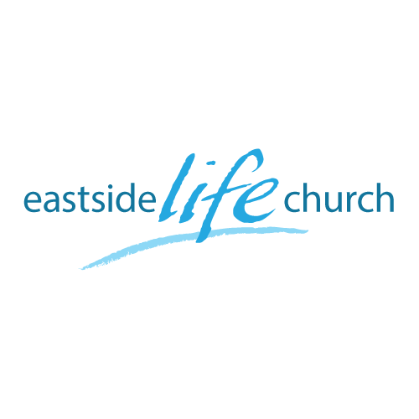
October 14th 2018

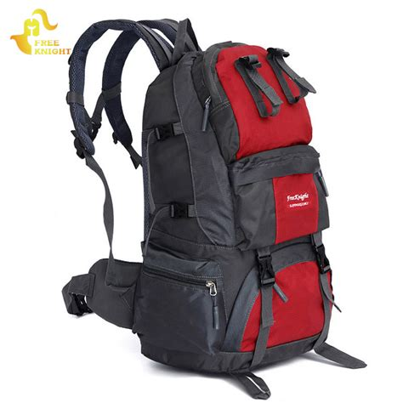

Back to Church - 6
“ The People God Uses”

Welcome
The first Sunday of the Rest (Best) of your life

2018

Back to Church– Part 6
“the People God Uses ”

Isaiah 6:8
Also I heard the voice of the Lord, saying, Whom shall I send, and who will go for us? Then said I, Here am I; send me.

The people God used in the early Church

Ex fishermen
Doubters
Intellectuals
Men & women…
Anyone who was..

- Imperfect: God matures (perfects) us as we respond to Him.
Acts 1:1-5 The previous week was filled with shortcomings.
- The available & connected: Acts 2:40-47
Key ingredients of the early church.

- Humble: prepared to receive.
(You can’t give until you have received first).
Eg Peter & John in Acts 3 & the lame man.

- Those who overcame problems and setbacks.
Acts 4: When they were forbidden to speak in Jesus name.

- Those open to the miraculous power of the Holy Spirit.
(Early Church was birthed in the miraculous, and carried the Gospel to the far reaches of the inhabited world with miraculous signs accompanying). Acts 1:8- 2:4

“God qualifies the unqualified”
We have no excuse.
With God all things are possible.

Final take Away & Communion

Jesus said: “ I am the way”

Together with Jesus (and one another) there is always a way:

A way out
A way forward
A way up…

