Notes

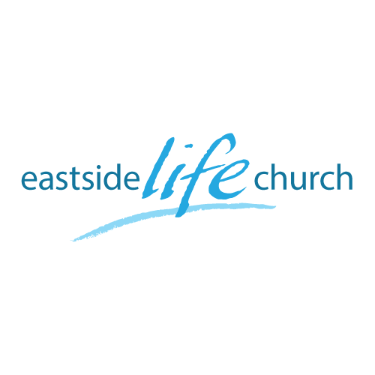
October 21st. 2018

Back to Church - 7
“ Connecting with God”

Welcome
The first Sunday of the Rest (Best) of your life

2018

Back to Church– Part 7
“Connecting with God ”

Acts 2:42
And they continued steadfastly in the apostles’ doctrine and fellowship, in the breaking of bread, and in prayers.

“Prayer alters destiny”

- Of individuals
- Groups (churches)
- Nations

What is your…BIG question about the why, what, how, when and who of prayer?

What we and God get out of prayer?

Matthew 6:9-13
Our Father in heaven,
Hallowed be Your name.
¹⁰ Your kingdom come.
Your will be done
On earth as it is in heaven.
¹¹ Give us this day our daily bread.
¹² And forgive us our debts,
As we forgive our debtors.
¹³ And do not lead us into temptation,
But deliver us from the evil one.
For Yours is the kingdom and the power and the glory forever. Amen.

- God’s kingdom rule is advanced on earth as it in heaven.
- We get our needs met.

Why is getting answers from God seemingly so hard?

- The Father’s good pleasure: Luke 12:32

- All His promises are yes and amen, not no or maybe!
2 Corinthians 1:20

Types of prayer

- Preparation of the heart: Acts 1:14
- Protection from enemies: Acts 4:24-31
- Promotion of the Gospel: Acts 10:2-4

Final take Away & Communion

It is through the power of the cross
That anything works.
Including
Prayer

