Notes

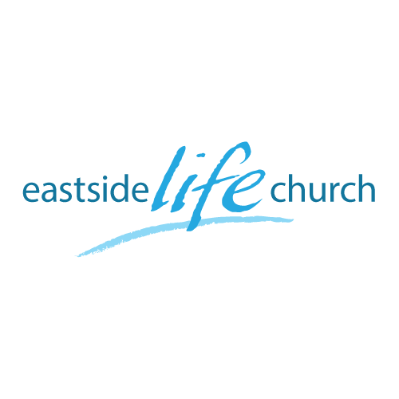
January 6th. 2019

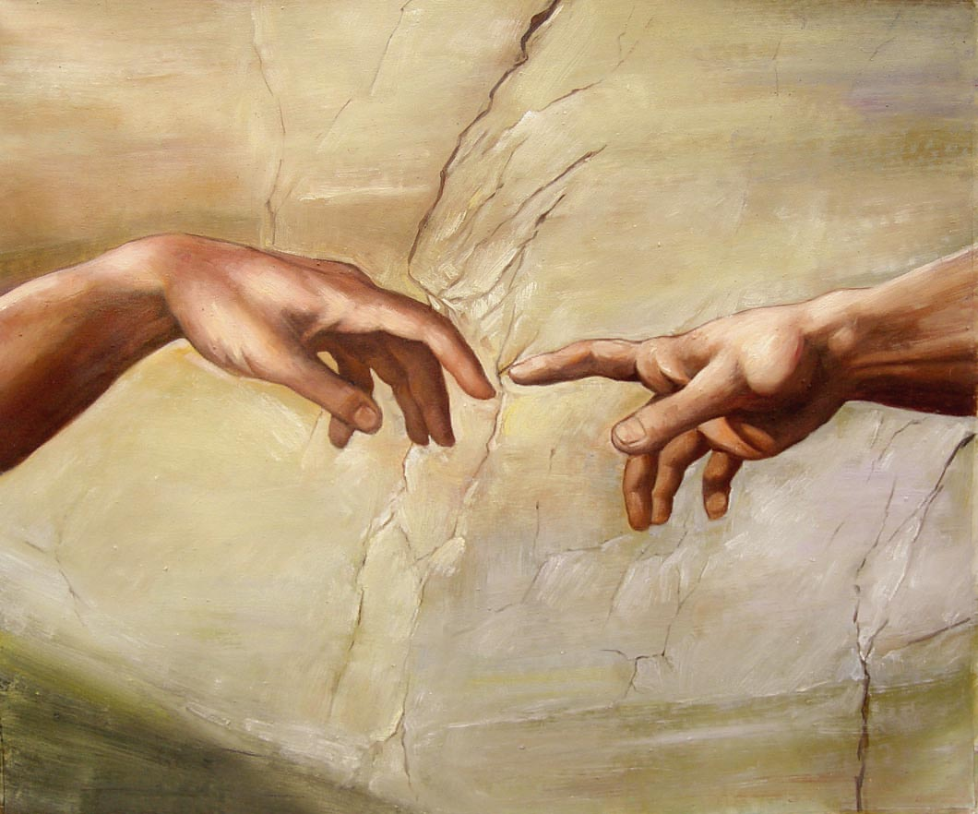

The Touch of God - 1
“First things First”

Welcome
The first Sunday of the Rest (Best) of your life

2019

The Touch of God– Part 1
“First things First”

Matthew 6:33
³³ But seek first the kingdom of God and His righteousness, and all these things shall be added to you.

Colossians 1:18
¹⁸ And He is the head of the body, the church. He is the beginning, the firstborn from the dead, that in all things He might have the preeminence.

Some Themes

Encounter / Enjoy / Express

Word / Worship / Wineskins / Works

Priesthood of believers / Increments / Growth

Worship & Word

‘Welcome Holy Spirit’

‘Waiting here for you’

‘Thank you’

‘The Lord our God’

Final take Away & Communion
“ Breakthrough Praise”

2 Samuel 5:20
²⁰ So David went to Baal Perazim, and David defeated them there; and he said, “The Lord has broken through my enemies before me, like a breakthrough of water.” Therefore he called the name of that place Baal Perazim.

‘Praise before Breakthrough’

